

Space, Range and Merchandising Programme

Business Systems Design
for
Space, Range and Merchandising Schedule

Author: David James

Date: 7Th July2006

Version: 2.4 - Draft

For sign-off:
Janet Smith (Version 1) |  | Space, Range & Merchandising Programme Director
Ewen Macinnes (Version 2) |  | Space, Range & Merchandising Programme Director
Danielle Coe |  | Range Programme 3 Project Manager
Adam Harrison (Version 1) |  | IT Space, Range and Merchandising Project Manager
Nick Robbins (Version 2) |  | IT Space, Range and Merchandising Project Manager
Marcel Borlin |  | IT Space, Range and Merchandising Programme Manager
Jim Clifton (Version 1) |  | Operations Team Manager
Mark Rappitt (Version 2) |  | Operations Team Manager
John Wootton |  | Range Programme Project Manager - Ranging System
Copied for information:
Steve Player | GT&A
Meryl Hanlon | IT Project Manager - Ranging
Mark Rappitt | Merchandise Analyst
Mark Croft | Operations Manger

Document Control
Date | Author | Change Description | Version
21/09/05 | D. James | Requirements | 0.1
27/09/05 | D. James | Added As-is and To-Be processes | 0.2
04/10/05 | D. James | Added high-level system design | 0.3
06/10/05 | D. James | Added detailed system design | 0.4
10/10/05 | D. James | Re-written to reflect spread-sheet solution | 0.5
12/10/05 | D. James | Reverted back to full solution | 0.6
18/10/05 | D. James | Add 'Release Event Infrastructure' | 0.7
24/10/05 | D. James | Feedback from reviews | 0.8
31/10/05 | D. James | Release for Business sign-off | 1.0
01/11/05 | D. James | Added Appendix A & B  Changes identified at the sign-off meeting  Add a load process from the modelling spreadsheet to the SCHEDULE application | 1.1
25/11/05 | N. Michell | Same as version 1.1 but without tracking the changes | 1.2
11/01/06 | D. James | Clarify that event id is based on launch date  Clarify that the spreadsheet must be completing valid before in can be uploaded  Remove a duplicated parameter from the list of parameters in the business process  Clarify the validation required to check that a store only exists once for the event or event and merchandising group  Change how event id is displayed when creating a new event | 1.3
15/05/06 | D. James | Same as version 1.3 but without tracking the changes | 1.4
25/05/06 | D. James | Re-baselined due to a number of change requests including  - Adding details of the tactical solutions  - Updating terminology  - Restricting some of the flexibility built into the schedule to cater for restrictions in the new ranging system  - The removal of store clusters for ranging events  This version has not been signed-off by the business users | 2.0
31/05/06 | D. James | Same as version 2.0 but without tracking the changes | 2.1
13/06/06 | D. James | Minor clarifications to the version 2.1 requested by the business team  Removal of the facility to assign merchandising groups to a space events  Essential Product Launches  Unlocking a locked planning group event | 2.2
04/07/06 | D. James | Same as version 2.2 but without tracking the changes | 2.3
07/07/06 | D. James | Updated reports to reflect change to approval process  Minor clarifications to version 2.3  Change of status when approving an unapproved event | 2.4
Contents

1 INTRODUCTION 7
1.1 Management Summary 7
1.1.1 Objectives of this document 7
1.1.2 Project Objectives 7
1.1.3 Background 8
1.2 Ranging Controls Infrastructure Overview 8
1.2.1 Ranging Controls Overview 8
1.2.2 Application Overview 9
1.3 Space, Range and Merchandising Schedule Overview 10
1.3.1 Deliverables 10
1.3.2 Benefits 11
1.3.3 Assumptions 11
1.3.4 Out of Scope 12
2 “AS IS” BUSINESS PROCESS 13
2.1 Introduction 13
2.2 Process Overview 13
2.3 The structure of the schedule 14
2.4 Plan and agree the schedule for the coming year 14
2.5 Maintain the schedule during the year 16
2.6 The life-cycle of a Ranging Event 17
2.6.1 Process and impact of Unlocking an Event 19
2.7 Use the schedule to drive retail and Management Information reports 20
2.7.1 Data Warehouse Reporting 20
2.7.2 GR Reporting 21
2.7.3 CR Reporting 21
2.8 Process for handling events in some stores only 21
2.9 Essential Product Launches 22
2.10 Expresses and Petrol Filling stations 23
2.11 Issues with Current Process 24
2.12 Current Architecture 25
3 “TO BE” BUSINESS PROCESS 26
3.1 The structure of the SCHEDULE 26
3.1.1 Merchandising Events 26
3.1.2 Space Event 27
3.2 Process Overview 27
3.3 Plan and agree the schedule for the coming year. 28
3.4 Maintain the schedule during the year 29
3.5 Use the schedule to drive retail and MI reports 30
3.6 Approve the event infrastructure 31
3.7 The life-cycle of a Merchandising Event 32
3.7.1 Process and impact of Unapproving an Event 34
3.8 The life-cycle of a Space Event 35
3.9 Essential Product Launches 35
3.10 Maintain the rules for schedule maintenance 36
3.11 Implications 38
3.11.1 Roles & Responsibilities 38
3.11.2 Sequence of events 38
3.12 System & Architectural Changes 39
4 REQUIREMENTS 40
4.1 Business Process Requirements 40
4.1.1 The Space, Range and Merchandising schedule will hold events. 40
4.1.2 The entries on the schedule will be fully validated 40
4.1.3 Identify stores associated with a Planning Group event 41
4.1.4 Essential Product Launch Events 41
4.1.5 Schedule History 42
4.1.6 Load the yearly schedule 42
4.1.7 Existing Business Processes 42
4.2 System Requirements 42
4.2.1 System Interfaces 42
4.2.2 Planning Group Event ID 43
4.2.3 System Parameters 43
4.2.4 On-line Screens 43
4.2.5 The SCHEDULE application should be easy to update and maintain 43
4.2.6 Reporting 44
4.2.7 History Requirements 44
4.3 Non-Functional Requirements 44
5 ISSUES & RISKS 45
5.1 Project Risk Log 45
5.2 Project Issue Log 45
6 SYSTEM DESIGN 46
6.1 High Level Processing 46
6.1.1 Add an Planning Group Event to the schedule 47
6.1.2 Amend an event on the SCHEDULE 48
6.1.3 View an event on the SCHEDULE 49
6.1.4 Delete an planning group event from the SCHEDULE 50
6.1.5 Manage Ranging Event workflow 51
6.1.6 Report Scheduled Events 52
6.1.7 Request a bulk load from the schedule modelling spreadsheet 53
6.2 Screens 54
6.2.1 Navigation Pane security 54
6.2.2 Find Screen 55
6.2.3 Enter a new event Screen 57
6.2.4 Assign merchandising groups to a planning group event 60
6.2.5 Assign store clusters to planning group event 66
6.2.6 Delete or view an event on the schedule 69
6.2.7 Update ranging event status 72
6.2.8 Report scheduled events screen 75
6.2.9 Upload Menu 78
6.2.10 Select File 79
6.2.11 Confirm Upload File 81
6.2.12 Upload Summary and Exception Report 83
6.2.13 Upload Confirmation and Error Report 85
6.3 Reports 88
6.3.1 Report scheduled events 88
6.3.2 Report a single event 90
6.3.3 Upload Exception Report 92
6.3.4 Upload Confirmation Report 93
6.4 Other Processes 95
6.4.1 Creating Essential Product Launch events 95
6.4.2 Deleting Essential product launch events. 96
6.4.3 CR daily interface 96
6.4.4 Data Warehouse interface 96
6.4.5 Range ODS 96
6.4.6 GR daily interface 96
7 STANDARDS 97
7.1 Screen & Report Design 97
7.2 Error Handling 97
7.2.1 Error Codes 97
7.2.2 Message Handling 100
7.3 Login & Security 101
7.4 Deletion Processing 101
8 NON-FUNCTIONAL REQUIREMENTS 102

APPENDIX A ABBREVIATIONS
APPENDIX B DEFINITION OF TERMS

INTRODUCTION

Management Summary

Objectives of this document
This document describes the Business Process and System design for the Event Schedule, which is part of Phase A of the new Space, Range and Merchandising Ranging Controls project.

This document has 2 main purposes

- To facilitate the business process and system design sign off with the business
- To enable progression to the technical system design

Sign off of this document is required to ensure that the solution design and final configuration will support the proposed processes and fulfil the business requirements

Project Objectives
The Space, Range and Merchandising Schedule (the SCHEDULE) will be one of the core components as part of the Space, Range and Merchandising “Ranging Controls Project”. The project was initiated to support the following goals:

- To provide the flexibility to support the new types of ranging carried out by the new Ranging System.
- To provide the capability to manage the infrastructure controls from one central location
- To allow the infrastructure control changes to be future dated
- To facilitate the migration of the infrastructure systems from the existing legacy system to new technology systems.
- To improve the control and accuracy of the information used to re-merchandise stores

Within the “Ranging Controls ”, and to support these goals, the Space, Range and Merchandising Schedule has the following objectives.

- To deliver a process and system to manage the Space, Range and Merchandising schedule
- To improve accuracy, and feed other systems with all relevant data for centrally controlled Space, Range and Merchandising events.
- Be the single source of data for all Space, Range and Merchandise events
- To create a clear and simple method to manage all Space, Range and Merchandising scheduled events.

Background
The current core Space, Range and Merchandising systems are having difficulty coping with the demands placed upon them by continued expansion of the business. Those difficulties include more flexible and varied ranges required for stores, high level of planning sophistication and number of stores, formats and store types.

The business is currently developing a new Ranging System to replace the existing tools and spreadsheets, thus removing the constraints and supporting future growth. To support the new ranging systems and other relevant developments within this area the Space, Range and Merchandising “Ranging Controls System” will create an infrastructure, which will facilitate and support all current and future Space, Range, and Merchandising activities.

A series of projects within the “Ranging Controls System” are planned to deliver the infrastructure required to support the new Ranging System and other systems

The Space, Range and Merchandising Schedule will deliver a set of controls to allow scheduled Planning Group EVENTS (definition within this document) to be created for both merchandising and space audit store activity. The SCHEDULE will also provide greater validation and user protection around data entry. This will then be the reference and control point for all scheduled activities for all other Infrastructure systems and activities

Ranging Controls Infrastructure Overview

Ranging Controls Overview
The schematic below represents the high-level proposed infrastructure and the relationships between to support the core business process.

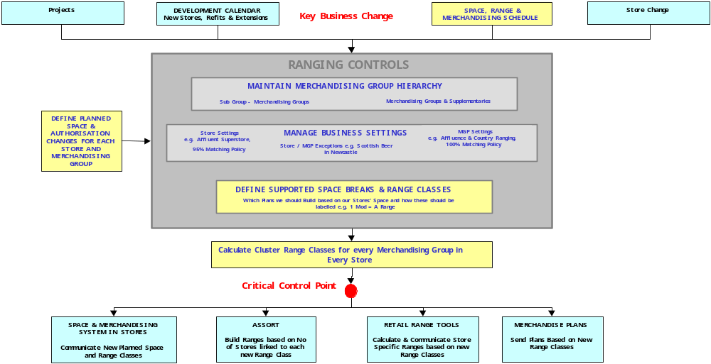
Figure 1: Infrastructure Overview

The following will describe briefly the function of the main applications within the Ranging Controls System. The Ranging Controls System will be configured, on a common platform, to support all Space, Range and Merchandising business processes. At this stage it is assumed that the following applications will be built to complete the infrastructure.

For more details surrounding the core business process in which the Ranging Controls Systems support please refer to the Ranging Controls System Business Process Design document.

Application Overview
The overall sequence of events within the infrastructure process is shown below.
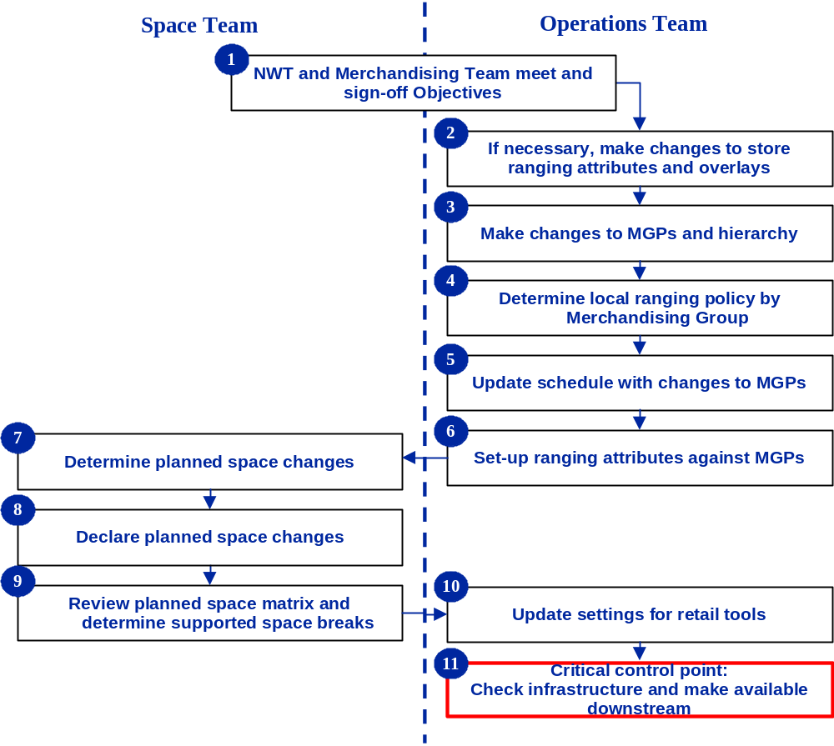

Space, Range and Merchandise Schedule – This application will support the set up and maintenance of scheduled events. It will also be the control point for sending approved data to other systems

Merchandising Group Maintenance – This application will support the maintenance centrally of all merchandising group data.

Pre-Ranging – This application will support the set up and maintenance of characteristics used in ranging merchandise groups. It then associates these characteristics to groups of stores (known as clusters) which are then used in ranging activities

Declaring Planned Space Changes – The Planned Space and Authorisation application will support the process to upload and make visible all multiple future dated planned space targets for any Merchandising group and store combination. Store merchandising group authorisation will be determined from these targets.

Equipment matrix – This application will allow the definition of equipment types and the Range to Space settings to be available to the Ranging Control System

Supported Merchandise Plans and ranges Matrix – This application will facilitate the creation, maintenance and making visible the current and future relationship between range class and space.

Controlling Cluster Range Classes – This application will calculate the range class for each store by merchandising group for the current and any future dates.

Impact Reporting – Although this is not a specific application, a suite of new reporting on the impact of any changes to the Ranging Controls will be available to enable signoff of each event.

Controls and Maintenance - This application will support the maintenance of all business parameters (controls), and also security and user access (maintenance) within all areas of the Ranging Controls infrastructure

Space, Range and Merchandising Schedule Overview

Deliverables
This project will deliver:

- A series of screens to allow the user to add a new event, amend or delete an existing event.
- On screen/printable reports of scheduled events.
- Facility to make the infrastructure changes associated to an Event available to other systems
- An updated definition of the roles and responsibilities relating to the completion of this task
- An updated business process for completion of the task
- Training materials and associated training for the user
- The transfer of the SCHEDULE to the Data Warehouse to facilitate ad-hoc reporting

Benefits
The key benefits that this project will deliver are:

- To enable efficient management of the relationship between future Space, Range and Merchandising events
- Simple visibility of all Space, Range and Merchandising Events to the business and other infrastructure systems.
- Enabler to allow linking of Planning Group Events within other infrastructure systems and processes.
- A more accurate schedule for Space, range and merchandising
- A more productive working process to maintain the SCHEDULE that is less reliant on manual processes compared to the current system.

Assumptions
The following assumptions have been made in order to design the solution to support the business process

- Screen prints included in this document are indicative only
- The Space, Range and Merchandising Programme's review of commercial reporting will identify any changes required to the Tracking Out of Cycle Changes report
- The Pre-Ranging system holds cluster information at store and store merchandising group level and therefore the sets of stores can be defined
- The Merchandise Plan Tracker phase 2 will be developed to work with the new SCHEDULE.
- If this project is implemented before the Merchandise Plan Tracker phase 2 project then the existing Merchandise Plan Tracker must be enhanced to work with the new SCHEDULE.
- Technical and business infrastructure will be in place
- Project can be delivered in isolation from other associated infrastructure
- IT support will be in place to sustain new technology
- Provided specific formats, merchandising groups and countries follow the documented process they are in scope
- The Pre-Ranging application will be able to provide a consistent view of the stores that were in each store cluster at the time an event was launched
- Every Planning Group Event and associated Range event entered onto the schedule will apply to all stores authorised for the merchandising group.

Out of Scope
The following is out of scope for this project within the infrastructure:

- Developments to other systems apart from the changes necessary to the Data Warehouse and CR systems to operate with the new schedule application.
- Design architecture for the Ranging Controls application
- Republic of Ireland
- Any store format or country that doesn't follow the current As-Is business process.
- Store driven specific EVENTS
- The UKBE business process

- Updating the CRS - Tracking Out of Cycle Changes report
- Creating a range event on the SCHEDULE at a lower level than all authorised stores
- This development will not initially be part of the 'Tesco-In-A-Box' application.

“AS IS” BUSINESS PROCESS

Introduction
The "AS IS" Business process described in this document reflects the expected Business Process that will be in place once the tactical schedule solution is in place for the new Ranging System.

The schedule is an activity calendar to show when stores are planned to complete various space, range and merchandising activities. It is used to plan when the head office activities to support a successful merchandising launch should be completed and to help plan when other initiatives can be launched in store. The schedule can hold any space, range and merchandising activity planned for the company but it is mainly used to just hold the merchandising activity.

Process Overview
The existing business process to manage the merchandising schedule can be split into three distinct parts.
- Plan and agree the schedule for the coming year.
- Maintain the schedule during the year
- Use the schedule to drive retail and MI reports

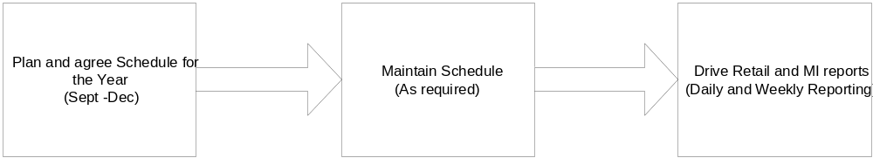
The current schedule applies across all Extra's, Superstores and Metros, as there is no mechanism to manage individual stores. The only method to stagger the launch across different store groups would be to launch the supplementary merchandising groups on a different date to the main merchandising group however this is not recommended as they have a common product hierarchy. It would not be possible to introduce any changes to the product range this way as other systems would launch these changes to all stores at the same time.

This schedule is not used for Express stores or Petrol Filling stations but there is separate schedule maintained for these.

The structure of the schedule
The merchandising schedule holds the details of the activities at merchandising group level but these are grouped together into Events identified by a Plan Group to make it easier to discuss and plan as shown below:

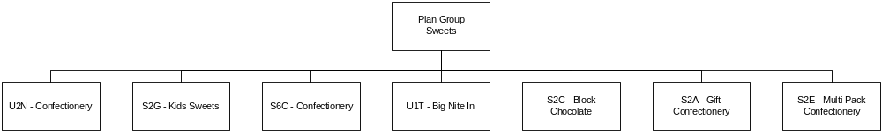
The relationship between Plan Group and merchandising groups isn't fixed so it would be acceptable to exclude Kids Sweets from the above and still call the group Sweets if it had been decided not to re-merchandise Kids Sweets.

Plan and agree the schedule for the coming year
The process to plan and agree the schedule for the coming year starts in September and finishes by December by which point the new schedule is agreed and available to the business.

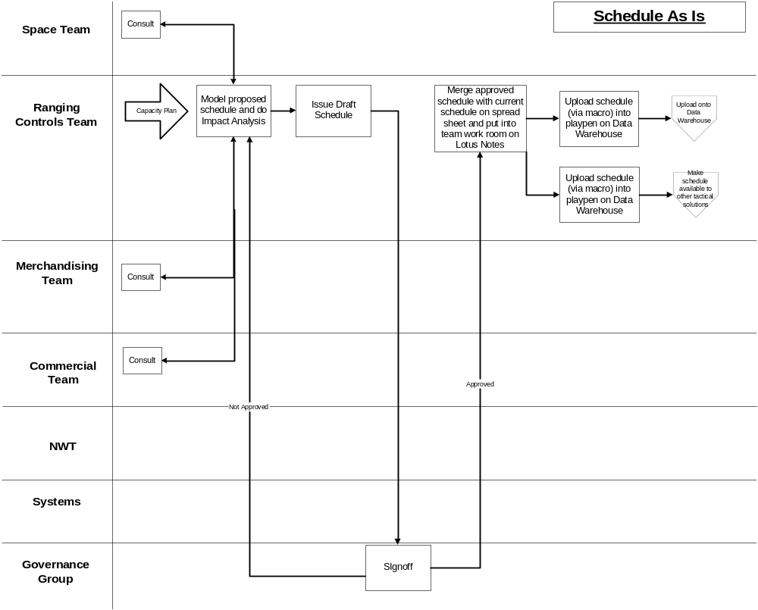

The process starts with a series of meeting between members of the Commercial, Merchandising and Space departments where each area puts forward their objectives for the coming year. These requirements will vary regarding how specific they are, for example all of these may be requirements:
- Merchandising group G2S wasn't done last year so ought to be done in the first six months.
- There needs to be a space audit just after Easter
- One of our main suppliers is launching 12 new lines in week 31 so these associated merchandising groups must be on the schedule that week.
- Seasonal changes e.g. Produce relay

All of these requests will be discussed and a high-level draft schedule agreed to satisfy as many requirements as possible. The Ranging Controls team will enter the draft schedule into a blank scheduling spreadsheet along with the shop hours required for each activity by format to produce a merchandising schedule that meets the detailed requirements and the retail constraints of hours available. During this process a number of compromises may have to be made with the original objectives.

When the Ranging Controls team have built a proposed schedule and validated it with the key stakeholders it is presented to the Governance meeting (Commercial, Property and Retail) for formal approval. The Governance group may require further changes to the schedule to meet other business objectives.

Once the schedule has been approved the Ranging Controls team merges the new schedule with any future schedule entries on the existing merchandising schedule spreadsheet within Lotus Notes workroom and uploads the information to the Data Warehouse, the GR and CR systems to be used for reporting. The Ranging Controls team must also upload the details from the new schedule into the tactical Schedule for use by the other tactical solutions for the new Ranging System. It is very important that the Ranging Controls team ensure that the same information is held in both tactical schedule and the main merchandising schedule passed to GR, CR and the Data Warehouse. If the business process does not enforce this then different areas of the business will be working to a different timetable for a merchandising launch.

The schedule is then uploaded into the Playpen area of the Data Warehouse from the spreadsheet, validated and passed into the Data Warehouse and the GR and CR systems overnight.

Maintain the schedule during the year
During the year there may need to be changes made to the merchandising schedule to support various initiatives, some of these may be supplier driven but the vast majority will be Tesco driven.

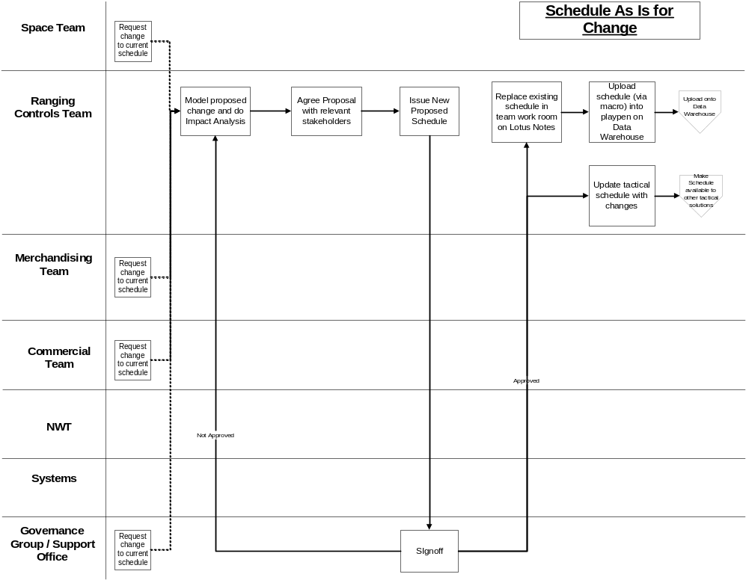

The Ranging Controls team can receive schedule change requests from Commercial, Retail, Space and the customer plan or alternatively they may need to change the schedule due to a policy change to the underlying business rules. In each instance the Ranging Controls team model the impact on the store hours using the merchandising schedule spreadsheet. When the Ranging Controls team deems the impact on store hours is acceptable they will communicate the change to affected stakeholders and issue a draft schedule to the Governance group or Support Office for approval. Once the changes are approved the spreadsheet is updated and the details uploaded to the Data Warehouse and the GR and CR system. The Data Warehouse will retain a historical view of all previous versions of the schedule to provide an audit trial. The Ranging Controls team must also update the tactical schedule with the same information to ensure that the new Ranging System has the same information as the other systems that use the SCHEDULE.

The life-cycle of a Ranging Event
This section describes how the internal status of a ranging event changes once Pre-Ranging has been implemented. The majority of these statuses are not visible to the User but are maintained internally within the system.

Once a ranging event has been added to the schedule it undergoes a number of different status until it is merchandising activity takes place in store or until the ranging event is cancelled. These different statuses are show below.
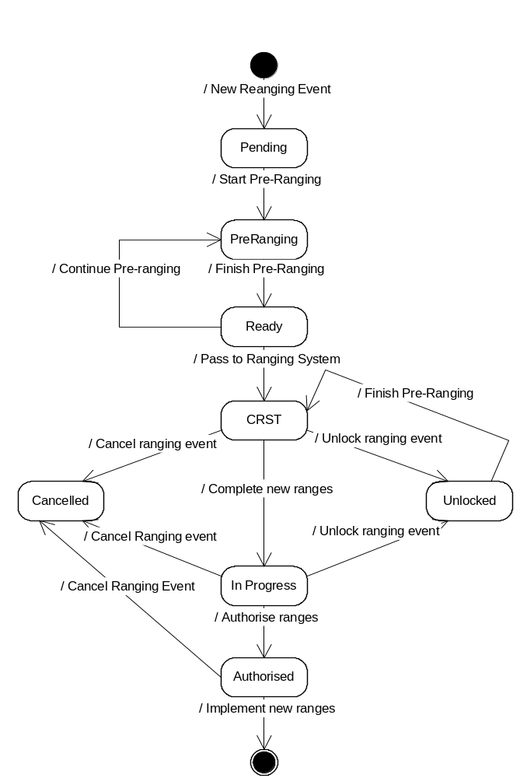
Pending Status
When a ranging event is added to the SCHEDULE it is always created with a 'Pending' status.

Pre Ranging Status
When the Ranging Controls Team is ready to start any Pre-Ranging work then they 'Unlock the New Event' by selecting the Planning Group description and merchandising group description on the Pre-Ranging screen to 'Unlock an Event'. This screen only lists ranging events with a 'Pending' or 'Ready' status and changes the status to 'Pre-Ranging'. It is currently necessary for the Ranging Controls Team to unlock every Ranging Event within the Pre-Ranging application even if there are no changes required within Pre-Ranging for the Event.

Ready Status
Once the Ranging Controls team has completed all of the Pre-Ranging work and the other work to change the infrastructure (e.g. planned space changes, determine supported space breaks and CW futures) they must 'Close' the event within Pre-ranging so that the details will be passed to the Ranging System overnight. The 'Close Event' screen lists all Ranging Events with either a 'Pre-ranging' or 'Unlocked' status. If the current status is 'Pre-Ranging' the status is set to 'Ready' whereas if currently the status is unlocked it is set to 'CRST'.

CRST Status
After the Ranging event details have been passed to the Ranging System overnight the status is automatically set to 'CRST'.

In Progress Status
Once the new ranges have been created within the Ranging System the Status is changed to 'In Progress' via the screen to send the range to merchandising within the Ranging System. This passes the range from the Ranging System to the Ranges in Progress (RIP) so the merchandising department may reconcile them.

Unlocked Status
It is possible that while Commercial are creating the new ranges associated with an event or the merchandising department are reconciling a range that some changes are required which require the Ranging Controls Team to make further changes to the Store Clusters or Overlays within Pre-ranging. If this is the case, and the range hasn't yet been authorised, the Ranging Controls Team may 'Unlock' the ranging event via the Pre-Ranging application. Once the additional changes have been made within the Pre-ranging application then the Event must 'Closed' again to update the Ranging System which sets the status to 'CRST'.

Cancelled Status
If it is decided to cancel an event after Commercial have started creating the new ranges then the Ranging Controls Team must set the status to 'Cancelled' within the Pre-Ranging application. Once a ranging event has been cancelled it is not possible to resurrect the event later so if the event is required at a later date it must be set-up on the schedule again and all the other work done again.

Authorised Status
The merchandising department will authorise each range within the Ranges On Progress system once they are satisfied that the range is fully supported by the store plans. This changes the status to 'Authorised'

Process and impact of Unlocking an Event
When a member of the Ranging Controls Team unlocks an Event the In Progress range is immediately deleted from the Ranges In Progress application and can be updated within the Pre-Ranging application by any user with override access.

If a new store cluster is created for an 'Unlocked' event then: -
- Overnight the new store cluster will be added to the Ranging Workbook
- The last authorised range passed to Ranges in progress will be recalculated overnight.
- The Ranging Control team must set up the supported space breaks and equipment types for the new store cluster

If a store cluster is removed for an ' Unlocked' event then: -
- All supported space breaks and equipment types for the store cluster are deleted immediately
- The store cluster will be removed from the Ranging System overnight
- The last authorised range passed to Ranges in progress will be recalculated overnight.
- If any plans have already been created in ProSpace for the store cluster they must be removed manually.

If a new overlay is created for an 'Unlocked' event then: -
- It will be available for use in the Ranging System the next day and will also be included within the ranges sent to Ranges in Progress
- It will be included in the FMPOG data imported to ProSpace from Ranges in Progress.

If an overlay is removed for an 'Unlocked' event then: -
- It will be removed from the Ranging System overnight.
- It will not be include in the FMPOG data imported to ProSpace from Ranges in Progress

Once the Ranging Controls team have made all the additional changes within Pre-Ranging the ranging event is once again closed within Pre-Ranging so that the Commercial team can complete building the new ranges before passing them to Ranges in Progress for reconciliation.

Process and impact of Cancelling an Event
When a member of the Ranging Control Team cancels a ranging event then: -
- The range will immediately be deleted from Ranges in Progress.
- All supported space breaks for the ranging event are deleted
- All equipment types for the ranging event are deleted
- Any overlay and ranging exceptions due to either start or end as part of the event will either be deleted or may carried forward to the next ranging event for the merchandising group if it hasn't yet been authorised.
- The ranging event will be removed from the Ranging System overnight
- Any sub-groups or product moves associated with the event are deleted from CW Futures

If a ranging event is cancelled after the end of week -6 and any sub-group or products moves have been associated with the event in CW Futures then those changes will already have been passed to CW. In this situation those changes must be manually backed-out in CW Futures and passed to CW before the event is cancelled.

Use the schedule to drive retail and Management Information reports
Once the merchandising schedule has been loaded to the Data Warehouse and the GR and CR systems it is used to drive a number of Management Information and Retail Reports on a daily or weekly basis.

Data Warehouse Reporting
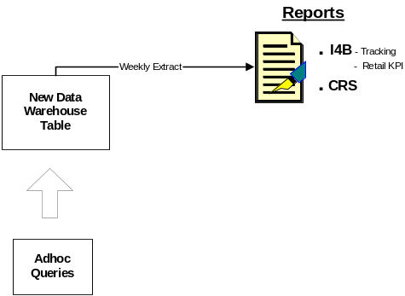

The processing cycle on the Data warehouse to produce the I4B and CRS reports continues regardless of whether the schedule has been updated or not each week. The three reports produced from the Data Warehouse tables are: -

- Tracking Out of Cycle Range Changes report.
This report shows out of cycle range changes and the RAG to identify late changes to the merchandising schedule.
- Existing Merchandise Plan Tracker report.
The current Merchandise Plan Tracker report shows if stores have implemented the merchandise plans on schedule.
- Retail Space, Range and Merchandising KPI report.
The Retail Space, Range and Merchandising KPI report will be launched next year to all Superstores and Extras and will show the forthcoming company schedule to the store.

GR Reporting
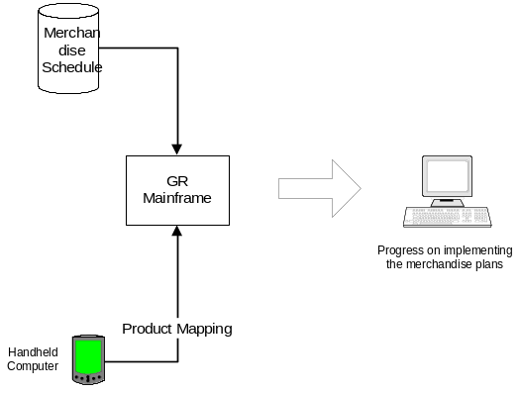
The GR system uses the Merchandising Schedule to identify when stores have been sent a new merchandise plan so that their progress on implementing the plan can be measured each day.

CR Reporting
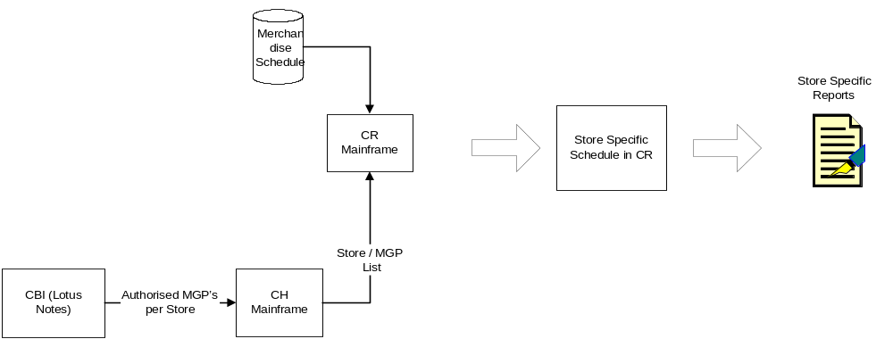
The CR system combines the merchandising schedule with the information held within CBI to produce a store specific schedule based on the authorisation of merchandising groups. This schedule then controls if a merchandising group appears on the Managing Your Range Report or the Weekly Range Change Update Report.

Process for handling events in some stores only
There are occasions where for business reason we only launch merchandising activities that impact some stores e.g. Re-merchandising Grocery areas in Extras during Quarter 1 of 2005/06. The existing merchandising schedule does not support this so it has been necessary for the merchandising team to communicate the event to the stores via email and to manually track how well the stores involved have implemented the change.

Essential Product Launches
The normal business process for scheduling range changes into the stores has already been described above but it has been recognised that it is not always possible to follow this process. There may be instances where it is necessary to make very small changes to the product range at short notice to meet business needs. These small range changes are termed 'Essential Product launches'. Essential Product launches would not have been added to the main merchandising schedule in the past however with the introduction of the Ranging System ALL range changes must be linked to an event on the tactical schedule even if they are not on the main merchandising schedule.

The diagram below describes the process used to manage Essential Product Launches.

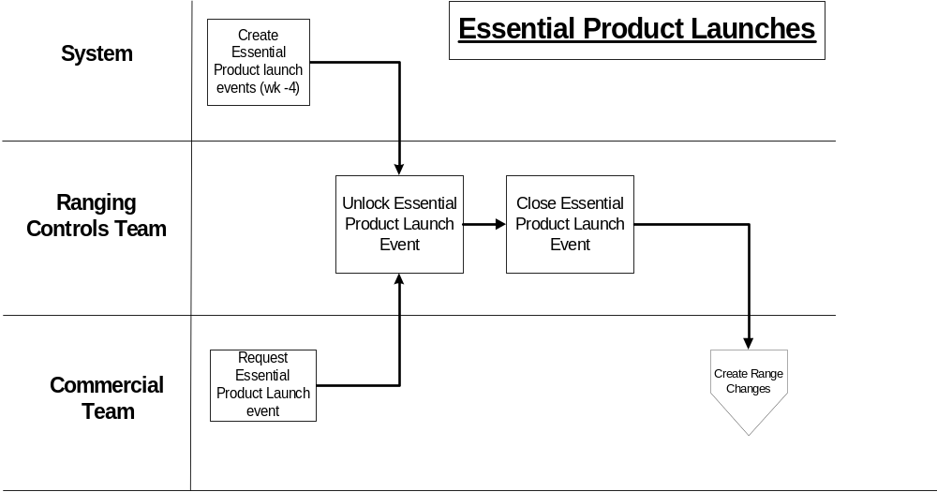
Every weekend the system automatically creates a planning group event with a launch date of the Monday of week + 4, for every merchandising group known to the system. Each of these planning groups contains a single ranging event. If the commercial team decide that they need to make a range change and there isn't a planned event on the schedule then they contact the Ranging Controls team to ask for the Essential Product Launch event for that week to be opened.

Once the Ranging Controls team have opened and closed the Essential Product Launch event the commercial team are able to access it the following day in the Ranging System. Once the Essential Product Launch event is visible in the Ranging System it can then be used in the same manner as any other event.

There are some important differences between using an Essential Product Launch event rather than an event already on the main merchandising schedule: -
- Range changes due to an Essential Product Launch event are reported on the Weekly Range Change report rather than the Managing Your range report.
- Stores are not tracked on the merchandise plan tracker
- Any new lines launched are reported on the MIS Out of Cycle I4B report

Expresses and Petrol Filling stations
Currently Express stores and Petrol Filling stations don't follow exactly the same process as Extras and Superstores.

Once the merchandising schedule has been agreed for Extra and Superstores it is passed to the Express and Petrol Filling Station (PFS) merchandising team as a basis to produce the Express merchandising schedule. The Express and PFS merchandising team will substitute the Express merchandising groups for the standard and supplementary merchandising groups on the schedule and then choose whichever week has the most change planned as the week for the Express merchandising group. It is often the case that the all the main merchandising groups that contain the same products as an Express merchandising group will be on the schedule for the same week. Once the schedule has been agreed it remains on a Spreadsheet within the Express and PFS merchandising team.

The Petrol Filling Station merchandising schedule is produced in the same manner but is based on the Express merchandising schedule.

The Express and Petrol Filling station merchandising schedules are not passed to either the Data Warehouse or the CR system. These stores therefore do not receive the Retail Space, Range and Merchandising KPI report, the Managing your range or the Weekly Range Change Update Report and neither are they currently tracked on how well they implement the merchandise plans.

Issues with Current Process
There are a number of issues with the current process.

Inflexibility:
- The merchandising schedule can only hold events linked to a merchandising group so is not suitable to hold events such as 'Clothing Audit' in the system.
- An entry on the merchandising schedule applies to every store using the merchandising schedule, so changes cannot be launched to only one store or one format very easily.
- It is not possible to stagger the launch of an activity across the company as every entry on the schedule applies to all stores.
- The schedule only hold the Tesco week of launch so it can not support Day of Week merchandising
- There is no concept of grouping related merchandising activity into a single event and using this to drive processing in other systems.

Complexity:
- Only one person at a time can maintain the existing merchandising schedule spreadsheet.
- Any changes that need to be made to the merchandising schedule must be made to the current spreadsheet and the tactical schedule used by the new Ranging System.
- The existing merchandising schedule spreadsheet is difficult to enhance and is only properly understood by very few people in the company.
- The initial load from the merchandising schedule spreadsheet to the Data Warehouse playpen sometimes takes a long while due to the method used to transfer the spreadsheet to the Data Warehouse

Strategic solution
- The current spreadsheet solution is not strategic and has issues regarding supportability, security and backup
- The spreadsheet solution is not formally maintained within the I.T. architecture and therefore is not robust, and cannot be easily used by other systems to co-ordinate events.
- The spreadsheet is not supported by I.T. support
- Anybody with access to the Data Warehouse playpen can amend the merchandising schedule while in is in the data warehouse playpen before it is transferred to the main table.
- The frequency of back up and ease of recovery is not adequate

Current Architecture
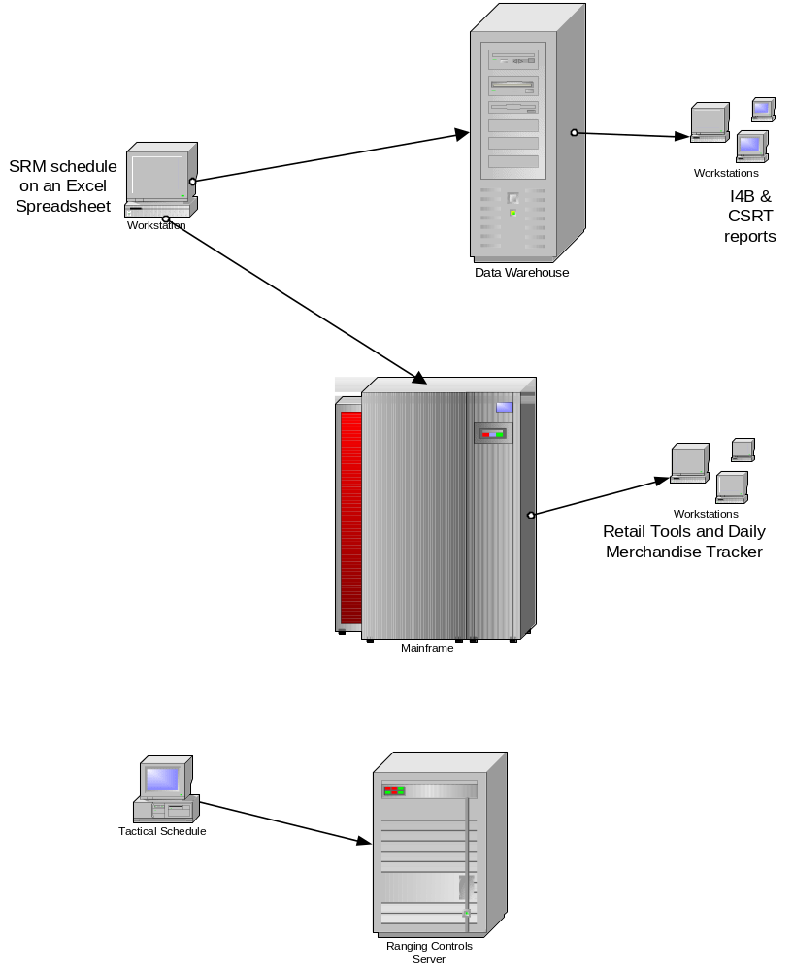

“TO BE” BUSINESS PROCESS
This section of the document describes the business process that will be in place once this development has been released.

The structure of the SCHEDULE
The Space, Range and Merchandising schedule contains two different types of entries, Space events and Merchandising events. A Space event is an activity in store that generally involves checking that the store has recorded space correctly but it does not involve any changes to the range of products stocked by the store or how those products are displayed. A merchandising event provides the centre with the opportunity to change the range of products stocked by the store and how these should be displayed.

Merchandising Events
The new Space Range and Merchandising schedule has extended the use of a Plan group to group together related merchandising activity. These plan groups will now be called PLANNING GROUP EVENTS and will be used to group together merchandising activities that are dependent on each other. Each of the individual merchandising activities is called a RANGING EVENT. A typical reason to link two ranging events together would be if space was moving from one merchandising group to another such as from Canned vegetables (G1A) to Soup (G1B) as it would not be possible to do one without the other. The process of grouping the related ranging events into a single planning group event makes it easier to ensure that everything needed to support the event is completed within the correct time-scales.

.Every ranging event on the new schedule applies to all of the store clusters defined within Pre-ranging for that ranging event. The store clusters must already have been created in the Pre-Ranging application. The actual stores affected by an entry on the schedule are determined by reference to the list of stores authorised for the merchandising group on the launch date (This information is held in Pre-Ranging).

The structure of a Merchandising Event is shown below: -
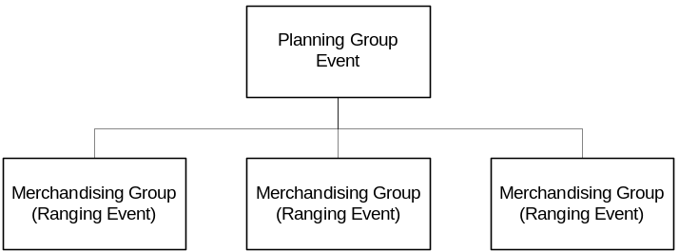

Space Event
There are two main differences between the structure of a Merchandising Event and that of a Space event: -
- It is possible to control the stores involved in a space event by assigning store clusters maintained in the Pre-Ranging application to the space event. This also allows a space event to be planned for different dates for each store cluster.
- It is not possible to assign merchandising groups to a space event, instead the store areas involved in the Space event are just described in the event description. This means that none of the systems using the schedule will be able to determine the merchandising groups impacted.
.
This structure is shown below: -

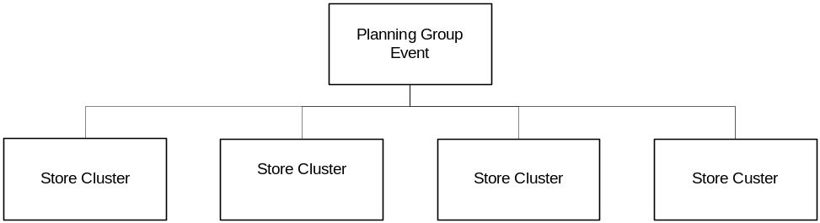

Process Overview
The three existing business processes are still required.
- Plan and agree the schedule for the coming year.
- Maintain the schedule during the year
- Use the schedule to drive retail and MI reports

There are now a further two business processes - Approve the event infrastructure for the Ranging system and Maintain the rules for schedule maintenance.

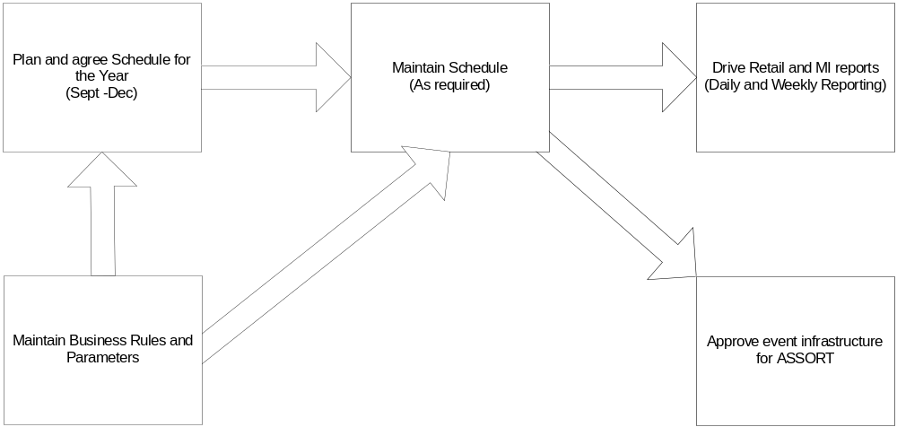

Plan and agree the schedule for the coming year.
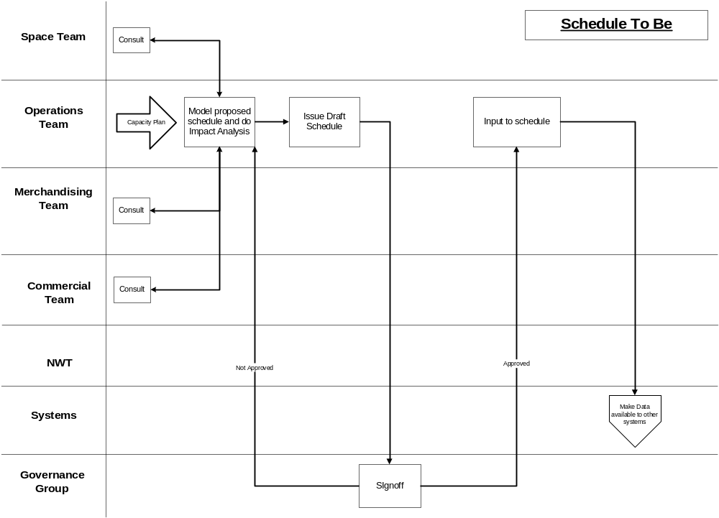
The business process to plan and agree the schedule for the coming year has not changed significantly as part of this development. The Ranging Controls team will still consult with all the interested parties and model the impact on store hours using a spreadsheet to produce a draft schedule. Once the Governance group has approved the schedule the Operations team will either enter the details into the SCHEDULE application or alternatively they will upload the details from the modelling spreadsheet to the SCHEDULE application. The upload process always loads the entire spreadsheet so any errors reported during the validation need to be resolved before the spreadsheet can be loaded.

The upload process can only be used to load schedule entries that launched after the latest launch date that is already held on the SCHEDULE. This means that if there were any events on the spreadsheet that had errors which the user decided to remove before loading the rest of the spreadsheet then the events with errors would have to be added later directly into the SCHEDULE application. The rejected events could not be uploaded by spreadsheet because the event date would now be less than the latest event date on the SCHEDULE.

The upload process will assume that each space event upload applies to ALL store clusters. If a space event does not apply to all store clusters then the Ranging Controls team must assign the correct store clusters after the schedule has been loaded.

There will not be any facility to re-run the upload process once it has completed so if any changes are identified then these must be made directly in the SCHEDULE application.

The details from the SCHEDULE application are made available to other Space, Range and Merchandising Infrastructure systems and the Data Warehouse each evening. Once an EVENT has been approved the details are also made available to the Ranging System, the Range Operational Data Store (ODS) and the Commercial Range database (CRDB) and the CR system each evening.

Maintain the schedule during the year

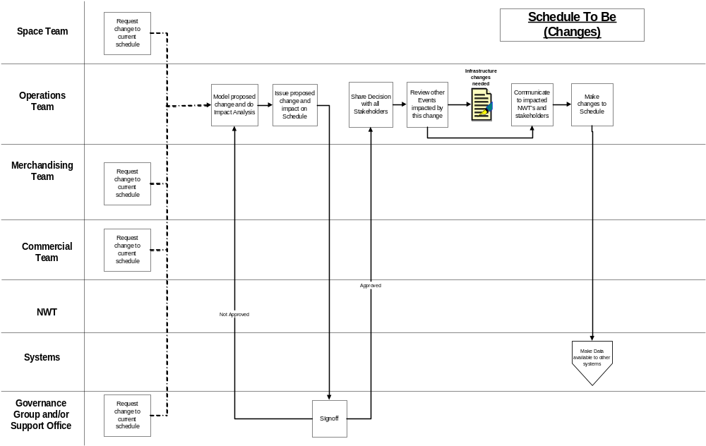
Whenever a change to the schedule has been requested, irrespective of whom has requested the change, the current business process to model the impact on the store hours using a spreadsheet will continue to be used. When reviewing the impact of any changes to the schedule the Ranging Controls team also needs to assess the impact of the change on any other events affecting the merchandising group. Once an acceptable recommendation is agreed between the stakeholders the Ranging Controls team issue the changes to either the Support Office or the Governance group depending on the timing and size of the change for sign-off.

Once the changes have been signed-off the Ranging Controls team update the details held within the SCHEDULE application. They then review the critical path of all of the affected and inform the relevant Natural Work Teams (NWT) of any changes about the new event timelines and the impact of the change.

Before an event can be deleted from the schedule the Ranging Controls team must manually ensure that all changes to the Space Matrix, Planned Space, Pre-ranging and the merchandising hierarchy have been removed for this event.

The details from the SCHEDULE application are made available to other Space, Range and Merchandising Infrastructure systems and the Data Warehouse each evening. Once an EVENT has been approved the details are also made available to the Ranging System, the Range Operational Data Store (ODS) and the Commercial Range DataBase (CRDB) and the CR system each evening.

Use the schedule to drive retail and MI reports
The current retail and Management Information reports that use the merchandise schedule will now be driven from the new Space, Range and merchandising schedule application. This has the following implications: -
- The Data Warehouse schedule tables will contain additional information to show if an event applied to ALL clusters or only selected clusters. It will not hold the details concerning which store clusters were associated with an event.
- The existing I4B Merchandise Plan Tracker and GR system reports will continue to determine which stores to track using the same process as now.
- The Retail, Space, Range and Merchandising KPI report will continue to use the current processing to determine when a store is on the merchandising schedule.
- The Tracking Out of Cycle Range Changes will be reviewed as part of the Programme's review of commercial reporting to ensure it meets the business requirements.

The decision within CR as to whether a store merchandising group should be appear on the Managing Your Range Report or the Weekly Range Change Update Report will continue to be based on the existing processing.

The stores in the store clusters assigned to a space event will be determined each day up until the launch date by the store clusters in force within Pre-ranging based on the store's current attributes. Once the launch date has been reached the stores on the schedule can no longer be changed.

Approve the event infrastructure
A new critical control point has been introduced to the overall ranging process to ensure that the commercial teams do not start to build product ranges until the Natural Work Team are happy that all of the infrastructure changes have been completed and meet the Event objectives.
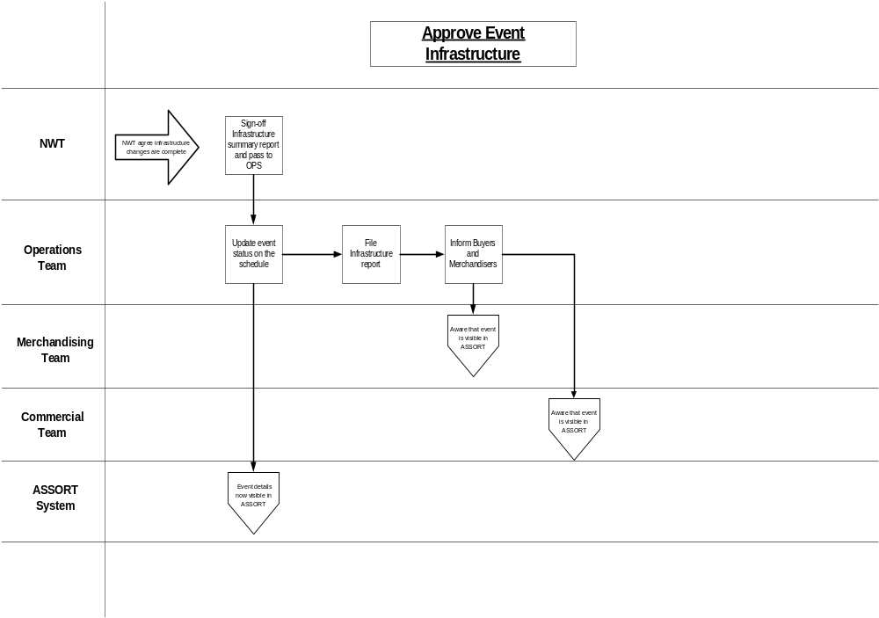
When the NWT is confident that all of the infrastructure changes for an event will enable the event objectives to be met they will pass the signed-off impact report back to the Ranging Controls team. The Ranging Controls team will update the schedule to reflect that the infrastructure changes can be made visible to the ranging system and other systems and file the infrastructure report for reference. The infrastructure report should be kept for reference until the next time the merchandising group appears on the schedule.

The life-cycle of a Merchandising Event
Once a merchandising event has been added to the schedule it undergoes a number of different status until the merchandising activity takes place in store or it is cancelled. The majority of these statuses are not visible to the Use but get set internally to control each ranging event. The different statuses are shown below:
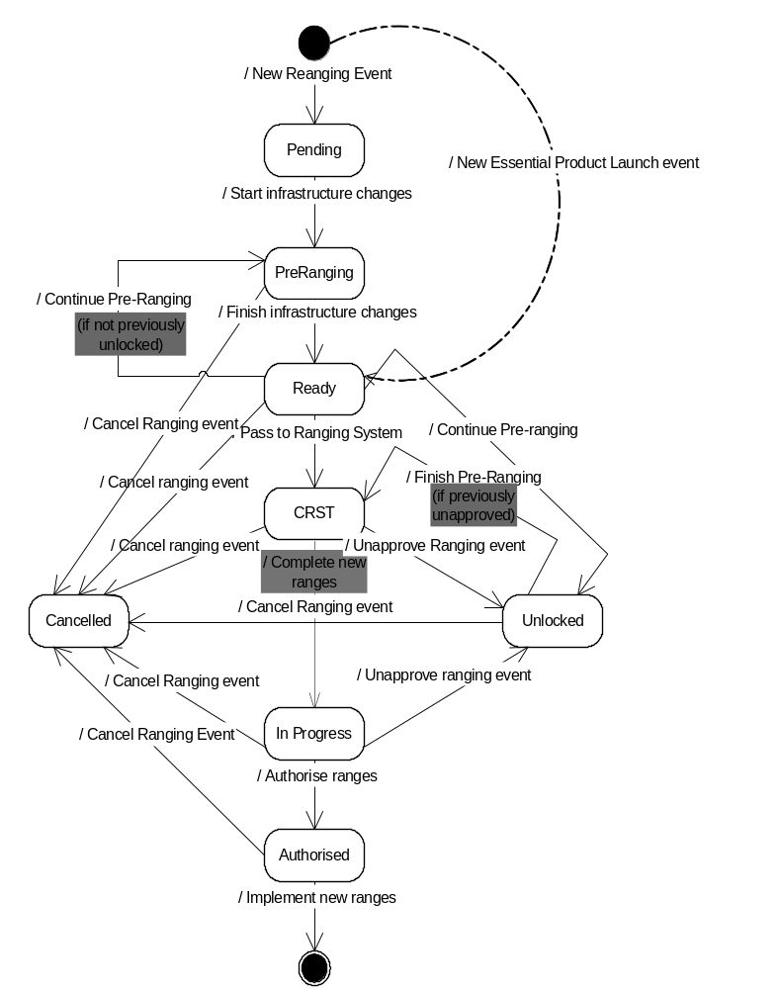

Pending Status
When a merchandising event is added to the SCHEDULE it is always created with a 'Pending' status unless it is an Essential Product Launch event in which case it is created with a status of 'Ready'.

Pre Ranging Status
Once the Ranging Controls team is ready to start working on the infrastructure for an event they must 'OPEN' the Ranging Event which updates the status to 'Pre Ranging'.

Ready Status
When all of the Pre-Ranging work and the other work to change the infrastructure (e.g. planned space changes, determine supported space breaks and CW futures) has been completed the Ranging Controls team must 'Approve' the event on the schedule. Overnight this passes the ranging event details to the Ranging System and the other systems.

CRST Status
After the Ranging event details have been passed to the Ranging System overnight the status is automatically set to 'CRST'.

In Progress Status
Once the new ranges have been created within the Ranging System the Status is changed 'In Progress' to pass the ranges from the Ranging System to the Ranges In Progress (RIP) so they may be reconciled by the merchandising department.

Authorised Status
The merchandising department will authorise each range within the Ranges in Progress system once they are satisfied that the range is fully supported by the store plans. This changes the status to 'Authorised'

Unlocked Status
It is possible that while Commercial are creating the new ranges associated with an event or the merchandising department are reconciling a range that some changes are needed which require the Ranging Controls Team to make further changes to the Store Clusters or Overlays within Pre-ranging. If this is the case, and the range hasn't yet been authorised, the Ranging Controls Team may 'Unapprove' the ranging event via the Schedule application. Once the additional changes have been made within the Pre-ranging application then the Event must be 'Approved' again to update the Ranging System, which sets the status to 'CRST'

Cancelled Status
If it is decided to cancel an event after it has been added to the Schedule then the Ranging Controls Team remove the merchandising group from the Planning Group on the Schedule which sets the status to 'Cancelled'. Once a ranging event has been cancelled it is not possible to resurrect the event later so if the event is required at a later date it must be set-up on the schedule again and all the other work done again.

Process and impact of Unapproving an Event
When a member of the Ranging Controls Team unapproves an Event the In Progress range is immediately deleted from the Ranges In Progress application and can be updated within the Pre-Ranging application by any user with override access. An event can only be unapproved if it hasn't been authorised and it is earlier than the Friday of implementation week -4.

If a new store cluster is created for an 'Unapproved' event then: -
- Overnight the new store cluster will be added to the Ranging Workbook
- The last authorised range passed to Ranges in progress will be recalculated overnight.
- The Ranging Control team must set up the supported space breaks and equipment types for the new store cluster

If a store cluster is removed for an ' Unapproved' event then: -
- All supported space breaks and equipment types for the store cluster are deleted immediately
- The store cluster will be removed from the Ranging System overnight
- The last authorised range passed to Ranges in progress will be recalculated overnight.
- If any plans have already been created in ProSpace for the store cluster they must be removed manually.

If a new overlay is created for an 'Unapproved' event then: -
- It will be available for use in the Ranging System the next day and will also be included within the ranges sent to Ranges in Progress
- It will be included in the FMPOG data imported to ProSpace from Ranges in Progress.

If an overlay is removed for an 'Unapproved' event then: -
- It will be removed from the Ranging System overnight.
- It will not be include in the FMPOG data imported to ProSpace from Ranges in Progress

Once the Ranging Controls team have made all the additional changes within Pre-Ranging the ranging event is once again approved within SCHEDULE application so that the Commercial team can complete building the new ranges before passing them to Ranges in Progress for reconciliation.

It is not possible to 'Unapprove' an Essential Product Launch event as the only reason to unapprove an event is to make infrastructure changes and infrastructure changes are not allowed against for an Essential Product Launch event.

Process and impact of Cancelling an Event
A ranging event can only be cancelled if it is earlier than the Friday of the implementation week -4 and there aren't any 'Authorised' ranging events due for a later date.

When a member of the Ranging Control Team cancels a ranging event then: -
- The range will immediately be deleted from Ranges in Progress.
- All supported space breaks for the ranging event are deleted
- All equipment types for the ranging event are deleted
- Any overlay and ranging exceptions due to either start or end as part of the event will either be deleted or may carried forward to the next ranging event for the merchandising group if it hasn't yet been authorised.
- The ranging event will be removed from the Ranging System overnight
- Any sub-groups or product moves associated with the event are deleted from CW Futures

If a ranging event is cancelled after the end of week -5 and any sub-group or products moves have been associated with the event in CW Futures then those changes will already have been passed to CW. In this situation those changes must be manually backed-out in CW Futures and passed to CW before the event is cancelled.

The life-cycle of a Space Event
The life cycle of a Space Event is much simpler than a merchandising event as every space event will be added to the Schedule already 'Approved'.

Essential Product Launches
The need to make very small changes to the product range at short notice still exists with the new system so the concept of 'Essential Product launches' remains. The Essential Product Launches will be added to the SCHEDULE automatically so that the range changes can be linked to an event within the Ranging System.

The diagram below describes the process used to manage Essential Product Launch events.
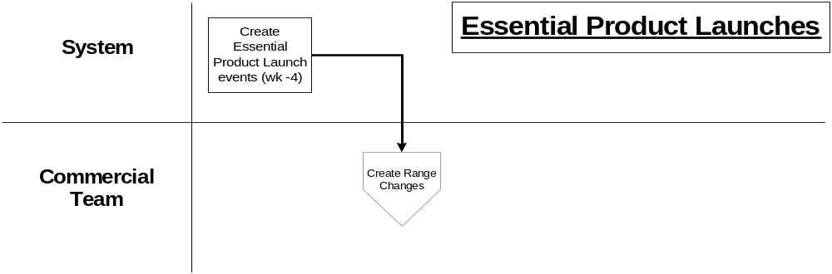
Every weekend the system automatically creates a planning group event with a launch date of the Monday of week + 4 for every merchandising department within the MGM system. Each planning group created will have a ranging event with a launch date of the Monday of week + 4 for every merchandising group within that department, if the merchandising group will be live on the launch date. The only exception to this is that if there is already a merchandising ranging event on the schedule for a merchandising group with the same launch date then an Essential Product launch event is not needed

If the commercial team decide that they need to make a range change and there isn't a planned event on the schedule then they can use the Essential Product Launch event, as it will have been passed to the Ranging System when it was created with a status of 'READY'.

There are some important differences between using an Essential Product Launch event rather than an event already on the main merchandising schedule: -
- Range changes due to an Essential Product Launch event are not reported on the Managing Your range report but can be if the Ranging Control team update the indicator by the cut-off date.
- By default stores are not tracked on the merchandise plan tracker but the Ranging Controls team can switch tracking on if required.
- Any new lines launched are reported on the MIS Out of Cycle I4B report

Maintain the rules for schedule maintenance
To help build flexibility into the new SCHEDULE application the business rules will be held as parameters within the flight deck maintenance application. These rules are unlikely to change frequently but will be maintained by the Ranging Controls team when they decide on a change. Whenever a business rule is changed it will be used to validate any schedule changes made after that date but will not be applied retrospectively to entries already on the schedule.

These parameters will include: -
- List of valid activity types and whether the activity type is a Range or Space activity
- The default values for Merchandise Plan Tracking indicator and the CR system indicator for each activity type.
- Percentage of Range change allowed for each activity type
- The minimum lead time required for an event
- Limit on the overall length of an event
- Limit on how far in future an event can be launched
- The number of weeks an Essential Product Launch event is created prior to the launch date
- The number of weeks an unused Essential Product Launch event remains on the schedule before it is deleted.

Most of the parameters can be amended without any adverse impact at anytime and the new value will be used straight away but will not affect any events already on the schedule.

E.G.
- If the limit on the overall length of an event is changed from two to three weeks then the user can enter a new event spanning 20 days straight away.
- If the limit on how far in the future an event can be launched is reduced from two years to one year and there is already an event on the schedule starting in eighteen months time it will not be impact by the change. However if later on there was a need to edit the event details the launch date would be validated against the new rules and rejected.

It must be noted that if the number of weeks an Essential Product Launch event is created prior to the launch date is increased then this will have the effect of introducing a gap in the schedule.

I.E.
If the number of weeks is currently 4 then at the start of week 30 Essential Product Launch events with a launch date of week 34 will be created. If during week 30 the number of weeks is changed to 5 then at the start of week 31 the system will create Essential Product Launch events for week 36. Therefore there will be no Essential Product Launch events for week 35 on the schedule.

The only parameter that behaves in a slightly different way is the amount of change allowed for each activity type. When this parameter is changed the new value will apply to all events approved for ranging system after this date whereas any approved before the change will still use the old value irrespective of the launch date.

There is no facility to amend the name of an activity type, so if it is necessary to change the name then the old one must be deleted and a new one created. It is not possible to delete an activity type if there are any entries on the schedule with that activity type.

Implications

Roles & Responsibilities
The following roles and responsibilities have been agreed for this project.

Who | What | Why | When
Operations Team | Add, update and maintain events | Manage unplanned changes | Ad-hoc
Operations Team | Produce Sign-off reports | Visibility of all activity (1 version) | Quarterly
Operations Team | Maintain parameters / rules for maintenance | One common agreed way of working | Annually
Operations Team | Propose six month schedule | Ability to facilitate critical path | Twice a year
Operations Team | Maintain schedule hours | To ensure retail workload is manageable | Annually
Merchandising team, Space team and commercial team (NWT) | Review schedule | Workload and/or resource planning | Weekly  (As appropriate for commercial)
Merchandising team, Space team and commercial team (NWT) | Propose change to schedule | To request a change to the schedule | Ad-hoc
Governance Group  (Steve Clarke) | Review & sign-off changes | Authorise store workload | Quarterly
Governance Group  (Steve Clarke) | Review & sign-off 6 months schedule | Authorise store workload | Twice a year
Retail Support Office  (Governance) | Own retail capacity planning | Authorise store workload | Ad-hoc

- The existing business process and system functions will continue to be used to agree the space, range and merchandising schedule for 2007/8 unless changed in a subsequent release.

Sequence of events
- Merchandising groups need to be defined within the Merchandising Group maintenance system before they can be added to the SCHEDULE.
- An event needs to exist on the SCHEDULE before the store clusters can be created or changed in the Pre-Ranging application.
- The overall process for a ranging event is therefore
- Create the event on the SCHEDULE
- Create any new merchandising groups or merchandising links within the Merchandising Group maintenance system.
- Add the merchandising groups to the event on the SCHEDULE
- Make any changes to the store clusters for the merchandising groups within Pre-Ranging

System & Architectural Changes
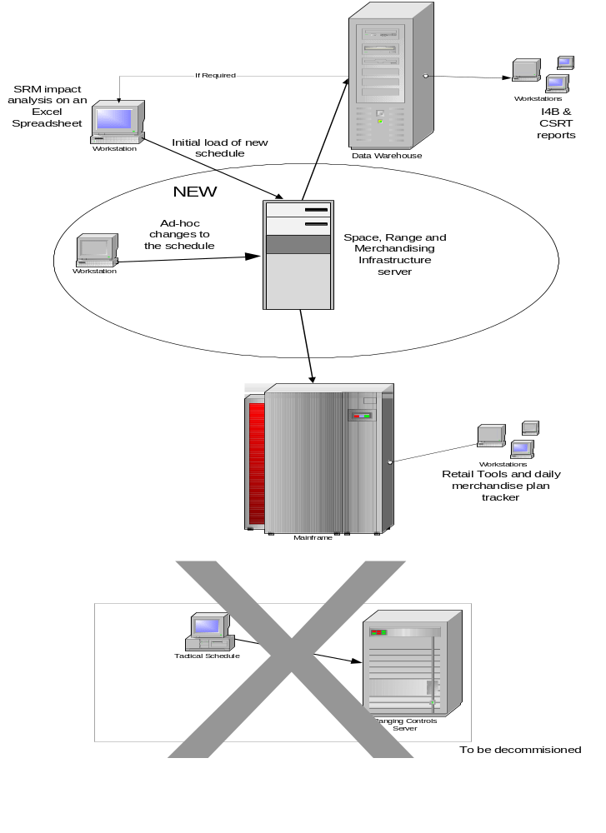

The Space, Range and merchandising application will be developed as a .NET application accessed via a web-browser interface and utilising a SQL server.

REQUIREMENTS
This section lists all of the requirements that need to be met by the Business Process and System Design to support the introduction of the new Space, Range and Merchandising Schedule in February 2007. The requirements are split into Business Process requirements that describe what the Business Process must achieve, System requirements that start to describe how the business process can be achieved and Non-functional requirements that describe some of the constraints on the overall system design.

The SCHEDULE application will hold all Space, Range and Merchandising events for all types of merchandising groups and store formats where the activity is driven from the UK centre. This therefore includes Space Audits, Out of cycle changes as well as merchandising activity.

Business Process Requirements

The Space, Range and Merchandising schedule will hold events.
A planning group event is a term that brings together different merchandising groups into a single business activity, e.g. 'Back to School' or 'Produce Seasonal change'. Each merchandising planning group event may consist of one or more merchandising groups that are due to launch within a short period of time. Space planning group events will not have any merchandising groups associated with them as they apply to a department e.g. Clothing Space Audit but may be associated with store clusters to identify the stores involved in the space event.

Each planning group event will have an event name, activity type and launch date. Each of the merchandising group entries assigned to a merchandising planning group event will have a launch date and certain information to support the existing merchandising schedule.

The entries on the schedule will be fully validated
The following rules will be applied to every schedule entry when it is entered or updated.
- The user cannot enter retrospective dates
- Only merchandising Groups that are live in Merchandising Group Maintenance, or will be live at the event launch can be linked to an event on the schedule.
- All activity dates must be set-up as actual dates e.g. dd/mm/yyyy and not as Tesco week number. The Tesco week number will still be shown on the schedule but calculated from the launch date based on the first day of the week being Sunday
- The launch date for an activity can be any point in the future but if less than six weeks from current date a warning will be issued and the date will need to be confirmed.
- If changes have been entered into the system for a ranging event then the launch date cannot be amended so that the new date leap-frogs another ranging event for the same merchandising group where changes have already been entered into the system.
- The launch date cannot be more than 2 years in the future.
- A merchandising group may only appear once for a planning group event.
- A merchandising group may only appear once for a launch date

Identify stores associated with a Planning Group event

Ranging Event
Prior to the launch date of a Ranging event the stores associated with it are controlled by the authorisation of the merchandising group within the CBI system. The SCHEDULE application does not need to check the authorisation as this has already been used within Pre-Ranging when the stores were determined. Once the launch date is reached then the stores are fixed according to the authorisation of the merchandising group on that date.

Space Event
The stores associated with a Space Event are controlled by selecting store clusters from the list created within Pre-ranging. The store clusters created at the store level in Pre-Ranging contain both authorised and unauthorised stores and consequently so will the space event on the Schedule.

Essential Product Launch Events
- A ranging event must be automatically created for every merchandising group for each week to enable essential product launches to take place without adding an Update event to the schedule.
- The essential product launch event should always be scheduled for Monday of the launch week
- The Ranging Controls team can manually create an Essential Product Launch ranging event on the Schedule.
- If an essential product launch event isn't required it should be automatically deleted four weeks after the launch date
- It should be possible to distinguish the essential product launch events from other events on the schedule just by looking at the planning group event id.
- By default the stores compliance with an essential product launch isn't tracked.
- By default stores do not receive the Managing Your Range report as a result of an essential product launch event. Range changes will be reported on the Weekly Range Change Update Report.
- The Ranging Controls Team must not be able to change another merchandising event into an essential product launch event or change an essential product launch event into a different merchandising event.
- An essential product launch event must immediately be available to the Ranging System without the need for the Ranging Controls Team to approve it.
- Other infrastructure changes and merchandising hierarchy changes should be prevented from happening as part of an essential product launch event.
- The MIS Out of Cycle I4B report should report all new product launches from an essential product launch event as Out of Cycle New Lines.

Schedule History
Once a scheduled event has launched all the details, including stores associated with each cluster must be kept for historical reporting but it will not be possible to amend any of the information.

Load the yearly schedule
- Once the yearly schedule has been agreed it should be possible to load the details from the schedule planning spreadsheet without re-keying all of the details.
- It should be assumed that each space event on the yearly schedule applies to ALL store clusters..
- It must not be possible to load any details to the schedule via the bulk load unless the earliest launch date on the bulk load is later than the latest launch date already on the schedule.

Existing Business Processes
The new business process must ensure that the existing business processes that use the current merchandising schedule can continue to work. The following reports have been identified as affected by the merchandising schedule: -
- Tracking Out of Cycle Changes report. (Any changes will be covered by the Programme's review of commercial reporting
- Existing Merchandise Plan Tracker report.
- The new Merchandise Plan Tracker report
- Retail KPI report.
- Retail Managing Your Range Report
- Weekly Range Change Update Report.
- Ad-hoc reporting from the merchandising schedule held on the data warehouse.

System Requirements

System Interfaces
The Space, Range and Merchandising schedule: -

- Requires an interface from the Pre-Ranging system containing the store level clusters.
- Requires an interface of valid merchandising groups from the Merchandising Group Maintenance System.
- Must provide an provide an interface for the Pre-Ranging System, Ranges in Progress, the ranging system, the Range ODS, Defining Supported Space Breaks (tactical solution)and CW Futures.
- Must provide an interface to the Data Warehouse to enable the existing Merchandise Plan Tracker report, Retail KPI report to continue being produced
- Must provide an interface to the Data Warehouse to allow ad-hoc reporting from the space, range and merchandising schedule.
- Must provide an interface to the CR system to enable the Retail Managing Your Range and the Weekly Range Change Update report to continue being produced.
- Must provide an interface to the GR system to enable the new merchandise plan tracker screens and report to continue being produced

Planning Group Event ID
The SCHEDULE application will automatically assign a unique random alphanumeric Event ID to every event on the schedule when the user adds a new event to the schedule or an event is loaded using the upload facility

System Parameters
All system parameters must be maintained via on-line screens within the system. These parameters cannot be maintained by every user of the system but only by a super-user.

On-line Screens
There will be screens to request an bulk load from the schedule planning spreadsheet as well as screens to add, amend, delete and view Space, Range and Merchandising events from the schedule. These screens will show which clusters are assigned to a space event but not which stores are associated to a cluster.

The screens will allow the user to select values from a list of valid values whenever possible rather than the user typing the details and the system then validating the information. E.G. When the user needs to add a merchandising group a list of valid merchandising groups should be produced on the screen so that the user can select the correct one.

To maintain an existing event the use can either enter the Event ID directly or alternatively use a search facility to select the event based on any combination of Event Name, Merchandising Group, Launch date or Tesco week number.

The SCHEDULE application should be easy to update and maintain
The system should: -
- Have the same look and feel as the other new applications being developed for the same users
- The capability to add new space, range and merchandising events in any date order.
- The ability to have multiple entries for the same merchandising group code provided that a merchandising group doesn't appear more than once for a launch date and only appears once within any planning group
- The capability to include all types of merchandising groups e.g. Express, supplementary.
- The ability to create a space or range event without any associated merchandising groups e.g. Space Audit
- Apply any change to the Planning group activity type or launch date to all the space or ranging events within the planning group.
- Check the impact on other ranging control system if a Planning group is deleted or a merchandising group is removed from a planning group

Reporting
It must be possible to produce a hard-copy report of the Space, Range and Merchandising events for a specific time period or event. The reports will show which clusters are assigned to a space event but not which stores are associated to a cluster.

History Requirements
All operational data must be kept for the current and previous year.

Non-Functional Requirements
A comprehensive list of the Non-functional requirements can be found in the separate document that describes each of the Non-functional requirements that need to be met across all of the Infrastructure projects.

ISSUES & RISKS

Project Risk Log
Risk number | Risk & consequences | Likelihood | Impact
1 | There is a limited capacity of expert knowledge currently being shared across multiple projects | H | H
2 | Any change to roles and responsibilities following the signoff of the Business System Design could require re-work to the design, and hence increase costs and extend timelines. | M | H
3 | Transition plan from the As-Is process to the To-Be process is not yet identified, which may produce additional requirements for the project to enable rollout | M | H
4 | To provide the flexibility the business needs in the system some important controls are managed in the To-Be business process, and not the system, e.g. deletion of events, changes to Infrastructure outside of the critical path, which increases the risk of error. | M | H
5 | Aggressive timelines for delivery increase the probability of process or system design error | M | H
6 | All Infrastructure projects are interdependent in terms of system design and business process. Changes or delays to the delivery of any one project will impact on the delivery of all projects. | M | M
7 | Projects using a new technology which is unproven in Tesco. This may result in delay or changes, or additional expenditure. | L | M
8 | There may not be a suitable release scheduled for the CR system to enable the changes to the Managing Your range report and the Weekly Range Change Update report to be implemented at the optimum time | H | M

Project Issue Log
Issue number | Describe the issue and consequences | Impact
1 | Data Warehouse and Xansa teams are currently running at capacity and may not be able to take on new work in the necessary timescales | H
2 | Two systems/processes/critical paths will need to be maintained during the transition to the To-Be process | H
3 | Day to day operational issues and other existing projects impact immediate project activities and milestones | M
4 | Some preparatory work will need to be done before moving merchandising groups into the new system, for example to amend the infrastructure of merchandising groups where the relationship between space and range class is different for different clusters | M

SYSTEM DESIGN

High Level Processing
The application to maintain the Space, Range and Merchandising schedule comprises a set of screens to allow the User to Add, Amend, View, or Delete an event from the schedule in addition to a separate screen to allow the user to easily find the entry that they wish to amend. The application also provides comprehensive reporting of the details held down to store cluster level on the schedule and a screen to manage the overall life cycle of a ranging event. The information on the schedule is made available to other applications within the ranging controls system to validate many of the actions within these applications.

The SCHEDULE application is entered via an option on the ranging controls main menu, which also includes a maintenance option to allow the user to maintain the business rules and parameters, used within the schedule. When the SCHEDULE application is entered the 'Find Screen' is always the first screen presented to the user.

The left-hand pane of each screen contains a navigation bar to allow access to Setting up new event, finding an existing event, creating a report and managing the life cycle of the event as well as logging off the system. These options will only be available from the Find event, View event, Approve an event, View store clusters and reporting. When the user is on the Enter New Event, Assign merchandising groups to an event, assign store clusters, Delete an event or the Update Ranging Event status screen then they must either confirm or cancel the update which will then always return to the Find screen.

Add an Planning Group Event to the schedule

Purpose
The Ranging Controls team must add every Space, Range and Merchandising event to the SCHEDULE so that there is a complete record in a single place of all Space, Range and Merchandising work planned in store. It is especially important that all of the merchandising activities are entered, as there must be an entry on the schedule before any of the required changes can be made in the other Ranging Controls and Ranging applications. The user must have either WRITE or SUPERUSER access to the Schedule to add a planning group event to the schedule

Screen Flow
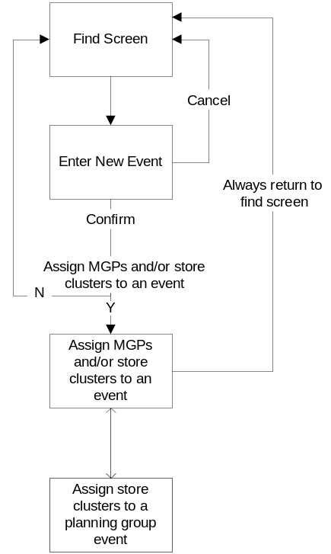

Process Flow
When the User needs to create a new event on the SCHEDULE they must create the event and associate any relevant merchandising groups and optionally store clusters for space events. It is possible that the merchandising groups and store clusters may not yet be created in the other applications so it is possible to just create an event without anything associated with it and then return later to add the other details via SCHEDULE maintenance screens.

The user enters the screen to create a new schedule event by clicking on the 'New Event' link on the left-hand side of the screen. The User will enter the event details on this screen. Once they confirm the details, the system creates the event and produces an dialogue box with the option to continue onto the screen to Assign MGPs and/or store clusters to the event or to leave the event set-up screens. If the user selects the option to add the MGPs and/or store clusters to the event the Assign Merchandising Groups screen is displayed where the user can either assign the store clusters to a space audit event or alternatively assign the merchandising groups to any event. Once the merchandising groups affected by this event have been picked the store clusters for each merchandising group within a space event can be selected if required but this can be added later if necessary. Whenever the user wants to add new store clusters to the planning group event for space events then a separate Pop-Up window is produced where the user can select from the store clusters created in Pre-Ranging.

Amend an event on the SCHEDULE

Purpose
The amend screens allow the Ranging Controls team to change any of the details associated with an planning group event provided that it has not yet launched in store.

The user must have either WRITE or SUPERUSER access to the Schedule to amend an event.

Screen Flow
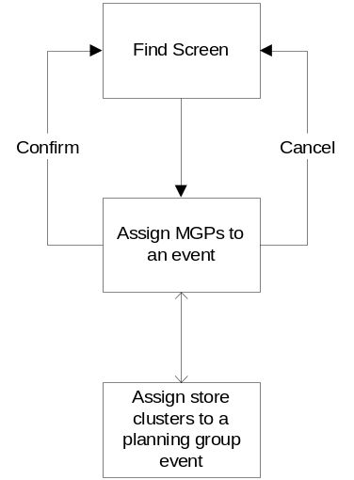

Process Flow
The User can either enter the Event ID directly onto the Find screen and click the Edit Event button or more likely will use the search facility on the find screen to narrow down the events listed by entering any combination of event name, launch date or type. Once the required event has been selected from the Find screen the edit button will take the User to the Assign MGP's to event screen. This screen is the same screen as the Assign MGPs' to an event screen used while adding an event and will allow both the merchandising groups and store clusters associated with an event to be changed. The user can only select the 'assign store clusters to a planning group event' screen to change the store clusters associated with a planning group event if it is a space event.

View an event on the SCHEDULE

Purpose
The view screens allow the Ranging Controls team to enquire on the details associated with any event.

Any user who has access to the Schedule can use these screens to view the details.

Screen Flow

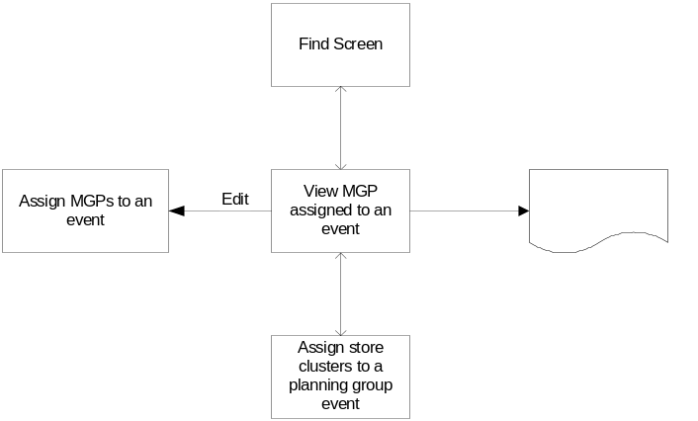

Process Flow
The User can either enter the Event ID directly onto the Find screen and click the View Event button or more likely will use the search facility on the find screen to narrow down the events listed by entering any combination of event name, launch date or type. Once the required event has been selected from the Find screen the view button will take the User to the Assign MGP's to event screen. This screen is similar to the Assign MGPs' to an event screen used while adding an event but will not allow any changes to be made but has a button to print all of the details for the event. The user can select 'assign store clusters to a planning group event' screen to view the store clusters associated with a space event but will not be able to make any changes.

Delete an planning group event from the SCHEDULE

Purpose
The delete screens allow the Ranging Controls team to remove an event from the SCHEDULE.

The User must have WRITE or SUPERUSER access to the SCHEDULE application before they can delete a planning group event.

Screen Flow
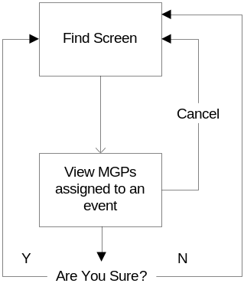

Process Flow
The User can either enter the Event ID directly onto the Find screen and click the Delete Event button or more likely will use the search facility on the find screen to narrow down the events listed by entering any combination of event name, launch date or type. Once the required event has been selected from the Find screen the delete button will take the User to the Assign MGP's to event screen. This screen is similar to the view screen with the addition of a button to request a delete but without the ability to switch to the assign store clusters screen.

Manage Ranging Event workflow

Purpose
The screen to manage the ranging event workflow allows the Ranging Control team to either: -
- Open a ranging event to allow the Pre-Ranging and infrastructure work to start.
- Approve a ranging event to show that all the Pre-Ranging and infrastructure work has been completed
- Unapprove a ranging event that has already been approved

The User must have either WRITE or SUPERUSER access to the SCHEDULE application to manage the ranging event workflow. Only users with SUPERUSER access may unappove a ranging event.

Screen Flow
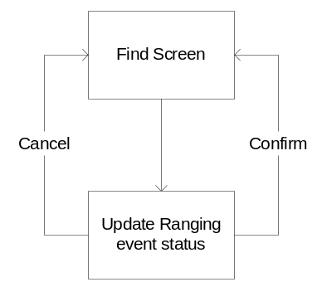

Process Flow
The User locates the planning group event that contains the ranging event they need to open and clicks on the 'Workflow' button which takes them to the 'Update Ranging Event Screen' that lists all of the merchandising groups within the selected Planning group event. The User selects the check-box to 'Open', 'Approve' or 'Unapprove' the relevant merchandising group. Once the user has updated the check-boxes they click the 'Confirm' button to update the status of the ranging events. If the User doesn't want to update the ranging event workflow they can 'Cancel' the operation so that they are returned to the 'Find Screen.

Report Scheduled Events

Purpose
The report of schedule events allows the Ranging Controls team to enquire on the details held in the schedule.

Any user with access to the Schedule application can request the report.

Screen Flow
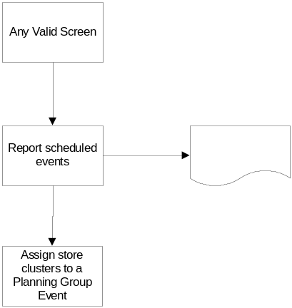

Process Flow
After the User enters this screen they enter the filter details to show the events they want to report. Once this information has been returned on the screen they can produce a hard copy via the Print button. This will print all of the details found not just the contents of a single screen. The user can see the store clusters associated with a space event by clicking on the associated clusters link which will take them to the 'Assign Store clusters to a planning group event' screen.

Request a bulk load from the schedule modelling spreadsheet

Purpose
These screens allow the user to transfer a new schedule from the modelling spreadsheet into the SCHEDULE application without the need to re-key all of the information.

The User must have SUPERUSER access to the schedule application and WRITE or SUPERUSER access to the Upload system before they can run a bulk load.

Screen Flow
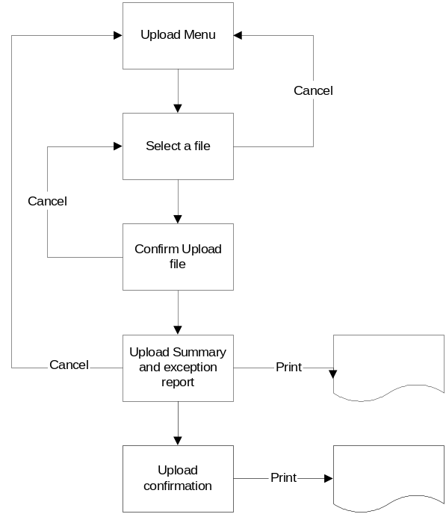

Process Flow
The screens to request a bulk load of the SCHEDULE from the schedule modelling spreadsheet are entered via the Upload menu on the Ranging Controls Menu. This screen allows the user to select the required upload, in this case the Space, Range and Merchandising Schedule initial load. The following screens allow the user to select the correct file, which will produce a validation report. Once all of the details are valid the user can then load all entries to the SCHEDULE. If a Planning Group Event contains more than one row on the spreadsheet and any of the rows contain an error then the entire EVENT is rejected rather than just the row with an error.

Screens
The screens illustrated within the BSD do not represent the final version of the screen but do identify all of the information that will be on the final screen.

Navigation Pane security
The options on the left-hand navigation pane are only active if it is valid to use that option from a particular screen AND the user has sufficient security access for that function otherwise the navigation link is 'Greyed Out'. The following tables shows which options are active for each level of access.

 | READ | WRITE | SUPERUSER
New Event |  |  | 
Find Event |  |  | 
Report an Event |  |  | 

Find Screen
The Scheduled event Find screen is the initial entry screen for the application and allows the Ranging Controls team to locate an existing event or jump to the event entry screen or the report screen.

Navigation

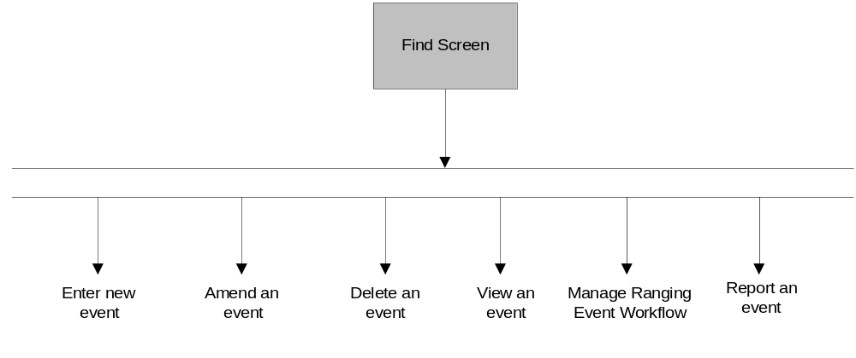
All of the left-hand menu options are active on this screen, if the user has sufficient access, except for the Find Event, as that would load this screen anyway. The user can navigate to any of the functions in the system from this screen.

Screen Layout
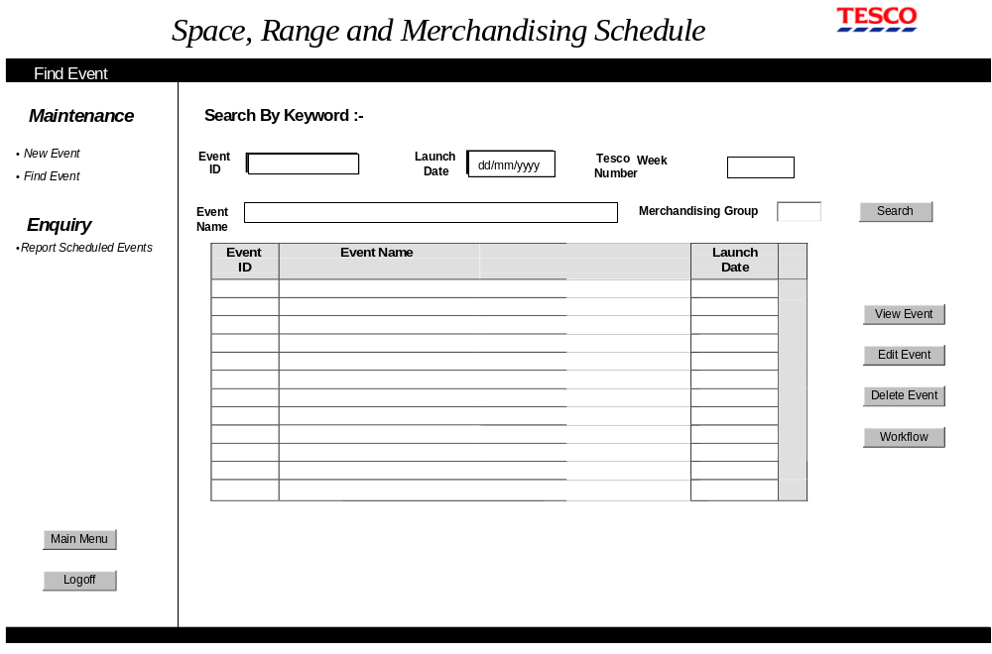On entry to this screen the cursor should be positioned in the Event Id box and none of the buttons should be set as the default button.

Field Descriptions
Field | Description | Comments
Search Fields  Event id - 8 chars  Launch date - 10 chars  Tesco week number - as screen standards  Event name - 60 chars, but edit box can be reduced to 30 chars  Merchandising group - 3chars | The user can either enter the event id or a combination of one or more words from the event name and/or either the launch date or Tesco week. If more than one field is entered then the event must match both conditions before it is listed | Once the user clicks on the search button the events that match the search criteria are listed. If searching by Event Name only those events that match the WORD or PHRASE entered are returned.
Event ID - 8 chars | The Event Ids from the schedule where the event matches the search criteria
Event name - 60 chars, can wrap onto 2 lines | The Event Name from the schedule where the event matches the search criteria
Launch Date - as screen standards | The Launch date from the schedule where the event matches the search criteria .

Description of Screen Function
When the user first enters the find screen it is always completely blank. The user enters the event id or a combination of partial event name, launch date, Tesco week or merchandising group and when the user clicks the search button those events that meet the criteria are returned within the list box. The partial event name entered should only cause those events where all the WORDS entered are found in the description irrespective of the sequence and case. When searching on merchandising group the system returns all planning groups that have a ranging event for the requested merchandising group. If the user clicks the search button without entering any search criteria the system will list all entries on the SCHEDULE. Once the list box has been populated the user can select one of the events and then click on the View, Edit, Workflow or Delete button to transfer to a screen to complete the action.

If any of the Planning group events returned by the search have been flagged for deletion then the entry should still be listed on the result grid but 'greyed out'. In this case the Event Name should be prefixed with 'DELETED - ' and it will not be possible to select the event and transfer to another screen using the Action buttons on the right of the screen.

Validation and error handling

Field | Validation
Launch date | If invalid dd/mm/yy date format error 4
Tesco week number | If invalid Tesco year week (yyyyww) error 16
 | If no event found that matches search criteria error 15
 | If the option to edit or delete an event is selected and the launch date of the event is not in the future then error 5.
 | If the option to edit or delete an event is selected and the launch date of the event is within the minimum lead-time based on the control parameter and then error 31.
 | If the user clicks one of the 'ACTION BUTTONS' before selecting an entry from the GRID then error 58.
 | If the user clicks on the 'Delete' button and any of the merchandising groups within the planning event group have a status other than 'Pending' or 'Cancelled' then error 33.

Security Considerations
If the User only has READ access all of the buttons except 'View Event' should be 'Greyed Out' otherwise all buttons can be selected.

Enter a new event Screen
This screen allows the user to create a new Space, Range or Merchandising event on the SCHEDULE.

Navigation
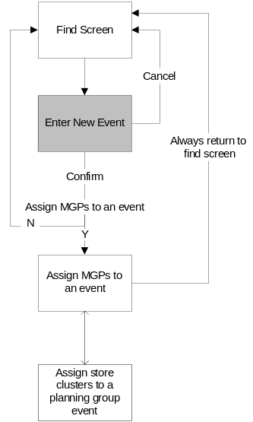

Once this screen has been entered none of the left-hand menu options are active so the only way to exit the screen is via the Confirm or Cancel buttons.

If the Confirm button is clicked a dialogue box is created to ask if the user wants to assign MGPs or store clusters to the event - if the reply is Yes then control transfers to the Assign merchandising groups or store cluster screen otherwise control returns to the Find Screen.

Screen Layout
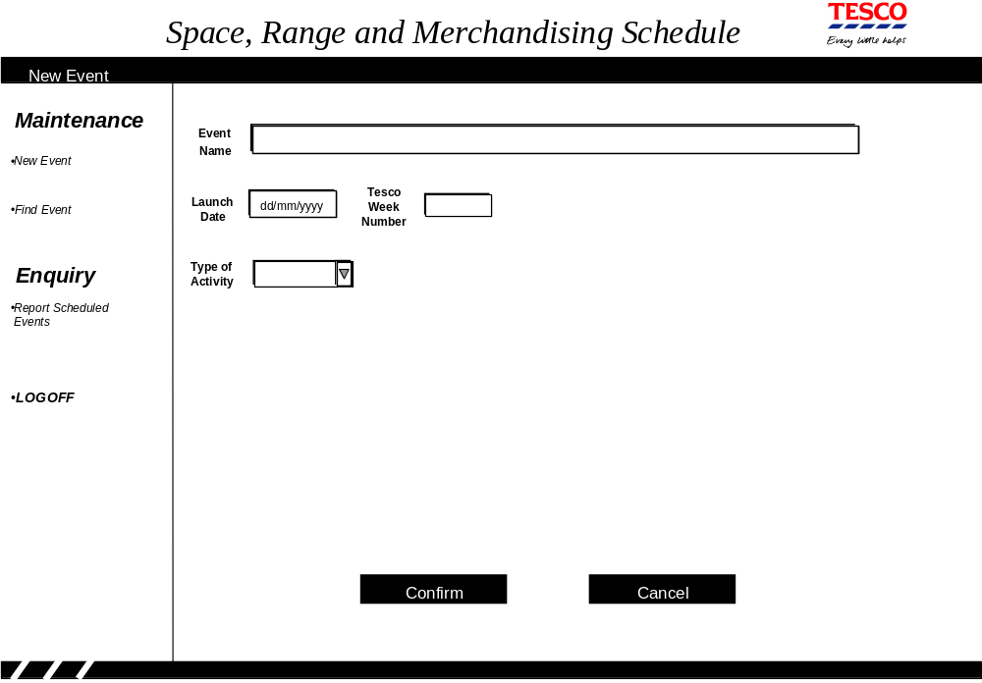
On entry to this screen the cursor should be positioned in the Event Name box and the 'Confirm' button should be set as the default button.

Field Descriptions
Field | Description | Comments
Event Name - 60 chars | A name to describe the event | The system will convert the EVENT Name to Uppercase.
Launch Date - as screen standards | The launch date of the planning group event this is normally the earliest launch date for a merchandising group associated with this event.
Tesco Week number -as screen standards | The system automatically converts the launch date to a Tesco week number. | The first day of the Tesco week is defined within the overall flight deck parameters
Type of Activity - 30 chars | Describes the type of activity that is being launched for this event. E.G. NEW, UPDATE, REFRESH, AUDIT | The list of valid activity types is maintained within the schedule parameters. The list should only include 'Essential Product Launch' if the launch date is within the next 4 weeks (parameter)

Description of Screen Function
The User enters the event title, type and launch date and the system displays the Tesco week based on the launch date and the start of week parameter. Once all the details are valid the User can confirm the creation of the event or alternatively cancel the entry at anytime. After the details have been confirmed the system generates the Planning Group Event ID in the format XXYXXMXX where: -

- XX - is the hexadecimal equivalent of a random number between 0 - 255
- Y - is the last character of the year the event was added to the schedule
- M - is the hexadecimal equivalent of the month the event was added to the schedule.

If the generated Planning Group Event ID already exists on the schedule another one will be generated until one is found that hasn't already been used on the Schedule. The system then displays dialogue box 34 so the user can assign merchandising groups to the event if required. If the activity type is an essential product launch then the first character of the Planning Group event ID is replaced with a 'Z' prior to checking that it is unique.

The system will also assign an internal numeric planning group event id.

Validation and error handling

Field | Validation
Event Name | If blank error 3
Launch date | If invalid dd/mm/yy date format error 4  If not in the future error 5  If to far in the future based on the control parameter error 6  If within the minimum lead time based on the control parameter then error 31

Assign merchandising groups to a planning group event
This screen allows the user to amend some of the event details as well as assigning merchandising groups or store clusters to an event.

Navigation
There are three distinct routes into this screen as it is used to either assign merchandising groups or store cluster when an event is created or to change those details when an event is amended

Create a New event | Amend an existing event
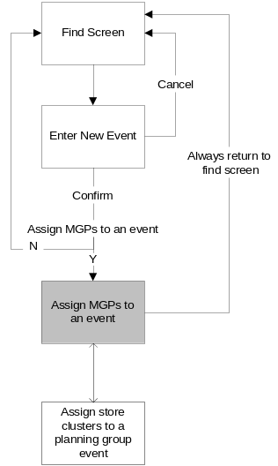 | 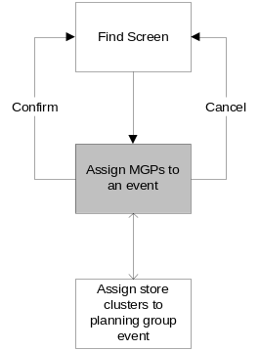 | OR | 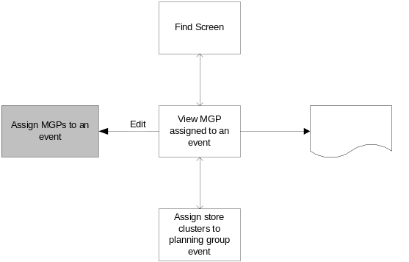

Once this screen has been entered none of the left-hand menu options are active so the only way to exit the screen is via the Confirm or Cancel buttons.

Screen Layout

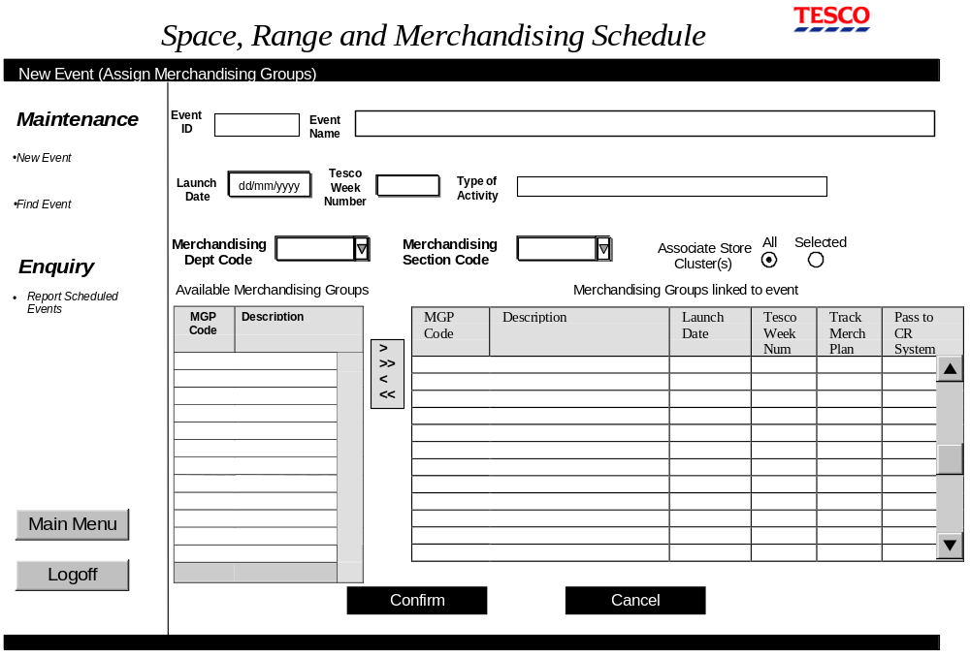On entry to this screen the cursor should be positioned in the Merchandising Department code box and the 'Confirm' button should be set as the default button.

The heading on the screen shows if it was entered to create or amend an event.

The Planning Group Event ID and Tesco week number can never be changed directly by the User on this screen.

The fields to associate store clusters directly to the planning group event are 'greyed out' unless the planning group activity type is a Space event. In this case the event is always associated with the store level clusters maintained within Pre-Ranging.

The fields to select a Merchandising Department Code and Merchandising Section code along with the Merchandising group tables are only shown on the screen for a Merchandising Event.

The type of activity drop-down list only contains the same sort of activity types as the original activity type associated to the planning group event. E.G if the original planning group activity was 'NEW' then the drop down list would only include 'NEW', 'REFRESH' and 'UPDATE' as these are all 'Merchandising Event' activity types but would exclude 'SPACE AUDIT' as it is a 'Space Event' activity type

When the screen is entered the list of available merchandising groups should initially include all merchandising groups that will be live on the MGM system on the event launch date. If the user is amending an existing event then any merchandising groups already associated with the event that don't have a current status of 'Cancelled' or 'Deleted' will be on the right. If an assigned merchandising group has a status of 'Authorised' then the fields to change the launch date, activity type and Pass to CR system indicator are 'greyed' out so that they can't be amended.

The details for an assigned merchandising group will only be populated when a merchandising group is transferred to the row otherwise the row will remain blank.

Field Descriptions
Field | Description | Comments
Event ID - 8 chars | A unique identifier for each event. This is from the previous screen | Cannot be edited on this screen
Event Name - 60 chars | A name to describe the event. This is from the previous screen
Launch Date -as screen standards | The launch date of the planning group event. This is from the previous screen
Tesco Week number - as screen standards | The system automatically converts the launch date to a Tesco week number. | The first day of the Tesco week is defined within the overall flight deck parameters.
Type of Activity - 30 Chars | Describes the type of activity that is being launched for this event. E.G. NEW, UPDATE, REFRESH, AUDIT. This is from the previous screen. | The list of valid activity types is maintained within the schedule parameters, for this screen it will only contain the activity types that belong to the same type of event as the original value..
Merchandising department code - 1 Char | A drop down box of all merchandising departments that will be live on the launch date according to the MGM system.
Merchandising section code - 1 Char | A drop down box of all Merchandising section codes that will be live on the launch date according to the MGM system and are within the selected departments.
Associate store clusters radio buttons | If the planning group contains space events then the user can choose to either select ALL store clusters or choose the store clusters from the next screen. | If the planning group contains ranging events then this option is 'greyed out'. If the user clicks the 'selected' button then the screen to select cluster is launched.  This will default to ALL clusters.
Available merchandising groups - 3 chars for MGP & 31 Chars for description, can be wrapped onto 2 lines | This should list all merchandising groups that will be live on the launch date according to the MGM system that are in the department and section selected by the drop-down boxes and not already linked to this planning group event. | When merchandising groups are transferred to the linked part of the screen via the transfer buttons they must be removed from this list.
Merchandising groups linked to the event.  3 chars for MGP | The merchandising groups that have been linked to this event.  The same merchandising group may appear more than once in this list | Merchandising groups can be removed from an event by selecting them from this part of the screen and using the transfer buttons. When a Merchandising group is removed it must be added back to the list of available merchandising groups if it is within the same Department and Section (if applicable) used to filter the list of available merchandising groups.
Transfer buttons | >  >>  <  << | Assign selected MGPs merchandising groups to the event.  Assign all MGPs in the available list to the event  Remove selected MGPs merchandising groups from the event  Remove all MGPs from the event
Assigned MGP - description - 31 chars, can be wrapped onto 2 lines | The description of the MGP from the MGM system | Populated when a MGP is assigned - can not be changed
Assigned MGP - Launch date - as screen standards | The launch date for this merchandising group. The field should initially be populated with the Event launch date. If the user amends the planning group launch date then each merchandising group launch date is reset to the same date as the planning group launch date. | Must be greater than or equal to the planning group event launch date.
Assigned MGP -  Tesco week - as screen standards | The system automatically converts the launch date to a Tesco week number. | The first day of the Tesco week is defined within the overall ranging controls parameters.
Assigned MGP -Track Merch Plan - 1 char | An indicator to show if the implementation of this merchandising event should be tracked on the I4B report | The drop-down has two values 'Y' and 'N' and should default to the value held against the activity on the parameters
Assigned MGP -Pass to CR system - 1 char | An indicator to show if this entry on the schedule should be passed to the CR system so that the sore receives the Managing Your Range report | The drop-down has two values 'Y' and 'N' and should default to the value held against the activity on the parameters

Description of Screen Function
When the user enters this screen to add or amend the merchandising groups or store clusters associated with a planning group event the list of available merchandising groups includes all those live on the MGM system at the launch date unless already assigned to this planning group. The drop-down merchandising department and section boxes initially default to space but can be to filter the number of merchandising groups shown in the available merchandising group section.

Once the list of available merchandising has been filtered down to a manageable list the user can select which merchandising groups, if any, are associated with the event. Whenever a merchandising group is associated with an event it will be removed from the list of available merchandising groups and added to the planning group event with a 'Pending' status.

A merchandising group with a current status of 'Pending' can be removed from a planning group event without any further validation checks. This will flag the merchandising group as deleted. However if the current status isn't 'Pending' further validation checks are required and system processing takes place to undo any ranging work that has already been completed. This is detailed below: -
- If there are any changes in the MGM system associated with this ranging event then display error 41 and do not remove the merchandising group.
- Display message 62 to allow the user to confirm the operation.
- Once the User confirms the operation the system checks if there are any Overlays for the merchandising group or Store / Merchandising Group exceptions that start or end on this Ranging Event.
- If any Overlays or exceptions exist and there is a future Ranging Event for this merchandising group that hasn't been 'Cancelled' or 'Authorised' then display message 63 to allow the user to either carry forward or delete the details.
- If the User decides to carry forward the overlays and exceptions to the next Ranging Event then the system transfers the changes to next ranging event.
- If the User decides to delete the overlays and exceptions or there isn't a future ranging event that they can be moved to the system will remove the details.
- The system deletes the In Progress range, store cluster, space matrix and equipment types associated with the ranging group event.
- If the cancelled ranging event was the first event for the merchandising group for CRST (i.e. a Rollout event) then the next non-cancelled event for the merchandising becomes the Rollout event.
- The current status of the ranging event is set to 'Cancelled'

If the user decides to change the planning group launch date then the new date will overwrite the existing launch date for the individual merchandising group events.

If the planning group event is a space event the only option available on this screen is to assign the store clusters to the event. This is done by either selecting the ALL clusters or SELECTED clusters radio button. If the SELECTED clusters radio button is clicked the screen to select the clusters is opened. It is important to ensure that whenever ALL clusters are selected any details regarding specific store clusters that may have been assigned in the past is completely removed.

Once the User clicks the confirm button the system will allocate the next sequential ranging event id to each new merchandising group within the planning group event and set the ranging event status to 'Ready' for an 'Essential Product Launch' and 'Pending' for all other merchandising events.

If the User has confirmed a change to the activity type for a merchandising event that has already been approved then the amount of change allowed for the activity type should be updated to the current value held on the parameter table. A ranging event has already been approved if the current status is either 'Ready', 'CRST', 'In Progress' or 'Authorised'.

Validation and error handling

Field | Validation
Event name | If blank error 3
Launch date  (Event and MGP)  If entered or changed on this screen | If invalid dd/mm/yy date format error 4  If not in the future error 5  If to far in the future based on the control parameter error 6  If within the minimum lead time based on the control parameter and then error 31  If the date is changed display warning message 47.  If the current status of the ranging event isn't Pending and the launch date is changed so that the sequence of ranging events (excluding all 'Pending', 'Cancelled' and 'Essential Product Launch' ranging events) for this merchandising group has changed then display warning 42. If the User confirms that the launch date should be changed then update the launch date.
MGP launch date and event launch date | If the MGP launch date is before the Event launch or after the Event launch date + maximum event window parameter date then error 32.
Associate store cluster radio buttons | If the SELECTED button is currently selected and the ALL button is then clicked display warning message 37 and only accept the change if the amendment is confirmed.  If the clusters are being changed when the launch date is within the next x days (where x is the minimum lead-time from the control parameter) then display warning message 38.
 | If a merchandising group is removed from the schedule and the launch date was within the next x days (where x is the minimum lead-time from the control parameter) then display warning message 38.
 | If a merchandising group with a status other than 'Pending' is removed and the current date is after implementation week - 4 display error 40
 | If a merchandising group with a status other than 'Pending' is removed and MGM changes exist for the ranging event then display warning message 41
 | If a merchandising group is already on the schedule for the same launch date then display error message 35

Security Considerations
A user must have SUPERUSER access to remove a merchandising group from a planning group event unless the merchandising group still has a 'Pending' status. If the user doesn't have sufficient access then display error 20.

Assign store clusters to planning group event
This screen only allows the user to assign selected store clusters to a space planning group event as merchandising events always apply to all stores.

Navigation
There are four distinct routes into this screen as it is used to either assign store clusters when an event is created, to change the store clusters associated with an event or to view those clusters.

Create an New Event | Amend an existing event | View an event
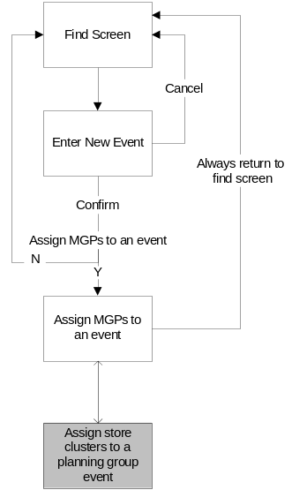 | 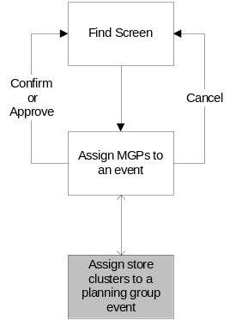 | 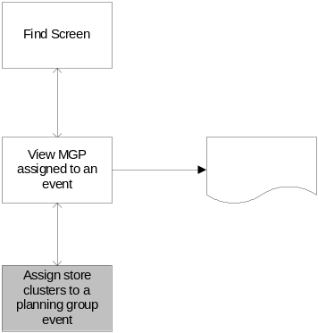
 |  | OR
 |  | 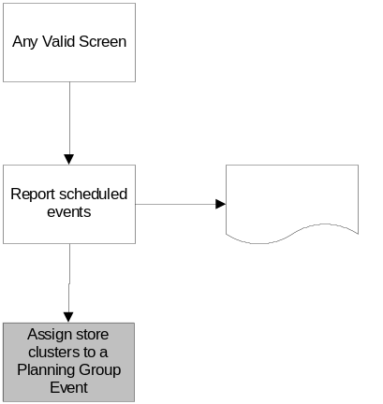

When this screen is entered as part of creating a new event or amending an existing event none of the left-hand menu options are active so the only way to exit the screen is via the Confirm or Cancel buttons. When the screen is entered as part of viewing an event all of the left-hand menu options are active dependant on the users security setting.

Screen Layout
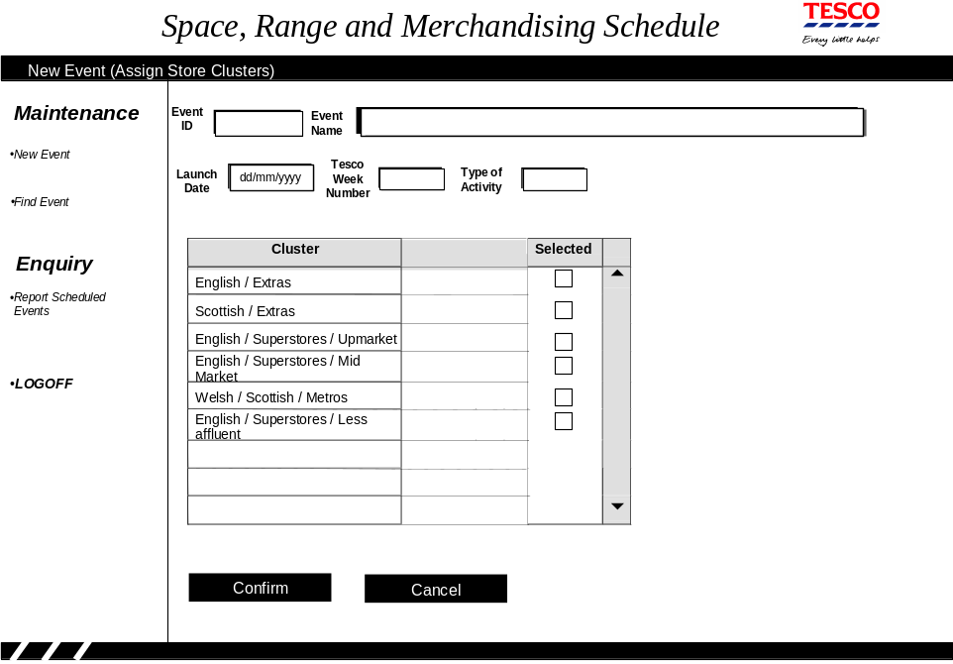
On entry to this screen the cursor should be positioned in the first check-box and the 'Confirm' button should be set as the default button.

The heading on the screen reflects the route taken to arrive at the screen.

The Event ID, Name, Launch Date, Tesco week number, activity type and merchandising group cannot be changed on this screen.

The list of available clusters is built from the Pre-Set Store level clusters defined in the Pre-Ranging application.

The 'confirm' button is disabled and none of the fields can be changed when this screen is entered via the Approve function or either of the View options.

Field Descriptions

Field | Description | Comments
Event ID - 8 chars | A unique identifier for each event. This is from the previous screen | Cannot be edited on this screen
Event Name - 60 Chars | A name to describe the event. This is from the previous screen | Cannot be edited on this screen
Launch Date - as screen standards | The launch date of the planning group event. This is from the previous screen | Cannot be edited on this screen
Tesco Week number - as screen standards | The system automatically converts the launch date to a Tesco week number. | The first day of the Tesco week is defined within the overall ranging controls parameters.  Cannot be edited on this screen.
Type of Activity - 30 chars | Describes the type of activity that is being launched for this event. E.G. NEW, UPDATE, REFRESH, AUDIT. This is from the previous screen. | Cannot be edited on this screen.
Store Clusters - 40 chars | The list of store clusters that are available from the Pre-Ranging application. | If any store clusters have already been selected the tick box should be populated. It is possible to select and deselect the store clusters by clicking the tick box

Description of Screen Function
This screen is used to select the store clusters associated with a space event. When the screen is first entered the tick box will show if any of the clusters have already been selected. If it is required to select some more clusters the tick box can be selected and alternatively clusters can be removed by de-selecting the tick box. If the Confirm Button is used to exit the screen then it should be closed and the changes applied to the database, alternatively if the Cancel Button is clicked the screen will close but no changes will be made to the database.

It is not possible to make any changes to the store cluster selection when the screen is entered via the Approve Option or either of the two View options.

Validation and error handling

Field | Validation
 | If any of the store clusters are changed and the launch date is within the next x days (where x is the minimum lead time from the control parameter) then display warning message 38.
 | If none of the store clusters have been selected then display error message 39.

Delete or view an event on the schedule

Navigation
There are two distinct routes into this screen as apart from using the screen to view the event details it is also used as a confirmation screen when deleting a planning group event.

Delete an event from the schedule | View an event on the schedule
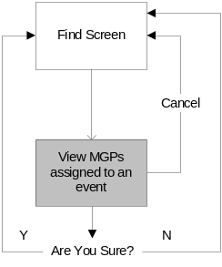 | 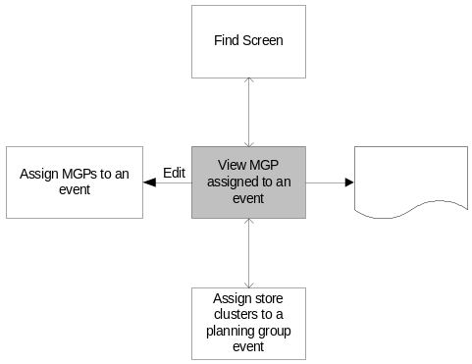

When the screen is used to view an event it is possible to navigate to the screen containing the store clusters by clicking on the SELECTED CLUSTERS radio button.

If the Confirm button is clicked on the DELETE screen a dialogue is created to warn the user that the action cannot be undone and to ask for final confirmation. If the User confirms the delete in the dialogue box the planning group event is deleted and an information message shown to confirm the delete has been completed. If the User doesn't confirm the dialogue then they remain on the DELETE screen.

When the screen is entered to delete an event none of the left-hand menu options are active so the only way to exit the screen is via the Confirm or Cancel buttons. When viewing an event all of the left-hand menu options are active depending on the user security setting.

If the EDIT button is clicked when viewing the event control is passed to the Assign merchandising groups or store clusters to an event to allow the user to change the event details.

Screen Layout
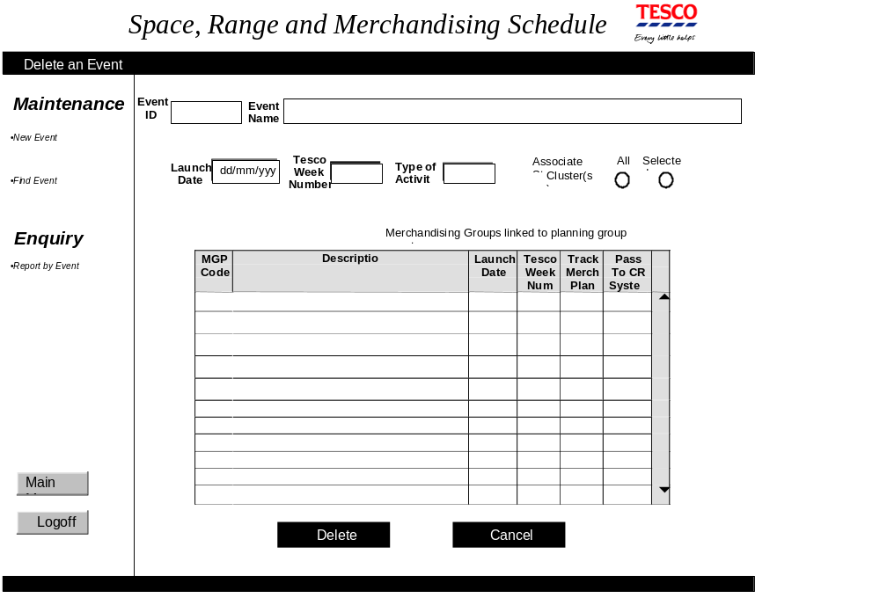
On entry to this screen the cursor does not need to be positioned and the 'Cancel' button should be set as the default button.

The heading on the screen reflects the route taken to arrive at the screen.

When the screen is used to view an event a PRINT button replaces the DELETE button and a new EDIT button is added to screen.

None of the information can be changed on this screen, however when viewing an event it is still possible to click the selected store clusters radio button to transfer to the 'Assign store clusters to a planning group event' screen.

Field Descriptions
Field | Description | Comments
Event ID - 8 chars | A unique identifier for each event. This is from the previous screen
Event Name - 60 chars | A name to describe the event. This is from the previous screen
Launch Date - as screen standards | The Launch date of the planning group event. This is from the previous screen.
Tesco Week number - as screen standards | The system automatically converts the launch date to a Tesco week number. | The first day of the Tesco week is defined within the overall ranging controls parameters.
Type of Activity - 30 chars | Describes the type of activity that is being launched for this planning group event. E.G. NEW, UPDATE, REFRESH, AUDIT. This is from the previous screen.
Associate store clusters radio buttons | The selected button is based on the current setting from the database. | If the planning group event contains ranging events then these buttons are 'greyed out'
Merchandising groups linked to the event. - 3chars | The merchandising groups that have been linked to this planning group event.
Assigned MGP - description - 31 chars | The description of the MGP from the MGM system
Assigned MGP - Launch date - as screen standards | The launch date for this merchandising group.
Assigned MGP -  Tesco week - as screen standards | The system automatically converts the launch date to a Tesco week number. | The first day of the Tesco week is defined within the overall ranging controls parameters.
Assigned MGP -Track Merch Plan - 1 char | An indicator to show if the implementation of this merchandising event should be tracked on the I4B report
Assigned MGP -Pass to CR system - 1 char | An indicator to show if this entry on the schedule should be passed to the CR system so that the sore receives the Managing Your Range report

Description of Screen Function
The Ranging Controls team uses this screen for two purposes: -
- to view an existing event and, if required, to print all of the merchandising groups and store clusters associated with and event.
- to check that the event they are about to delete is the right event

When viewing an event the cluster radio buttons show if the space events only apply to selected clusters and also provide a mechanism to view the clusters but it is not possible to change the setting of the radio buttons.

When viewing an EVENT the contents of the screen can be sorted by clicking on the column heading.

Validation and error handling

Field | Validation
 | If an event is deleted from the schedule then display warning message 45 and proceed with the deletion if the user confirms the action

Security considerations
If the user has entered this screen via the View Option on the Find screen and they only have 'READ' access to the SCHEDULE application then the EDIT button must be 'Greyed Out'.

Update ranging event status
This screen allows the user to 'Open a Ranging Event', 'Approve a Ranging Event' or 'Unapprove a previously approved Ranging Event'.

Navigation
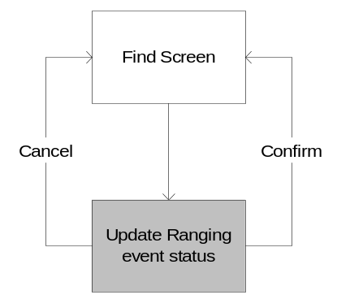
The only route to this screen is by selecting a planning group event from the 'Find' screen and clicking the 'workflow' button.

The only methods of exiting the screen are either by selecting the 'Confirm' button after choosing one or more merchandising groups or by selecting the 'Cancel' button.

If the Confirm button has been selected the user is returned to the 'Find' screen and message 42 displayed.

If the cancel button is selected the user is giving the option to proceed and if they continue they are returned to the 'Find' screen.

Screen layout
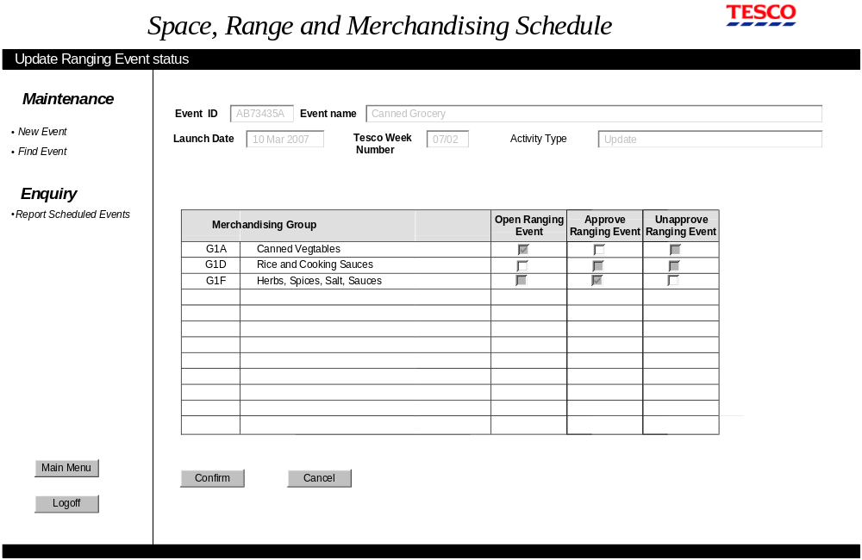
On entry to this screen the cursor does not need to be positioned and the 'Cancel' of the button should be set as the default button.

The title of the screen and column heading will reflect the option taken to enter the screen.

The only details that can be edited on this screen are the check-boxes against each merchandising group.

Field Description
Field | Description | Comments
Event ID - 8 chars | The Event Id carried forward from the 'Select Planning Group Event' screen
Event name - 60 chars | The Event Name carried forward from the 'Select Planning Group Event' screen
Launch Date - as screen standards | The Event Launch date carried forward from the 'Select Planning Group Event' screen
Tesco Week number - as screen standards | The Tesco week of the Event launch date carried forward from the 'Select Planning Group Event' screen
Merchandising group  3 chars merchandising group and 31 chars description | The merchandising group and description for each merchandising group within the planning event group | If the current status is cancelled the merchandising group is excluded from the table. If the current status is authorised the merchandising group should be 'greyed' out.
Open Ranging Event Check-box | The check-box is enabled if the current status of the ranging event implies that the ranging event may be opened. The check-box is ticked if ranging event has been opened. | If the current status is 'Pending' the check-box is enabled otherwise disabled.  If the current status is 'Pre-Ranging' the box should be ticked.
Approve Ranging Event Check-box | The check-box is enabled if the current status of the ranging event implies that the ranging event may be approved. The check-box is ticked if ranging event has been approved. | If the current status is 'Pre-Ranging' or 'Unlocked' the checkbox is enabled otherwise disabled.  If the current status is 'Ready', 'CRST', 'In Progress' or 'Authorised' the box should be ticked.
Unapprove Ranging Event Check-box | The check-box is enabled if the current status of the ranging event implies that the ranging event may be unapproved. The check-box is ticked if ranging event has been unapproved. | If the current status is 'Ready', 'CRST' or 'In progress' and the current date is before the Friday of the ranging event implementation week -4 the check-box is enabled otherwise disabled.  If the current status is ' unlocked' then the box should be ticked.

Description of screen function
The screen lists every merchandising group within the Planning Event Group that doesn't have a status of 'Cancelled'.

The check-boxes against each merchandising group are designed to show the current status of the ranging event and the only one enabled will indicator the next status for that range event. The check-boxes will appear in the following sequence:
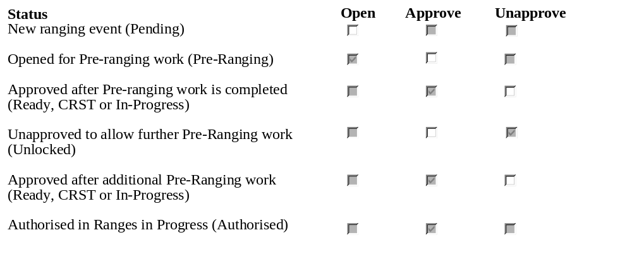
The only exception to the above table is that it is not valid to Unapprove an Essential Product Launch event therefore an Essential Product Launch event will always have all the check-boxes disabled with the Approve box 'ticked'.

Once the User has updated the check-boxes and confirmed the update the status of the ranging event is updated to reflect the new status. This is shown below.
Selected Check-box | New Status setting
Open | Pre-Ranging
Approve | Ready
Unapprove and current status is Ready and previous status has never been set to Unlock | Pre-Ranging
Unapprove and current status is Ready and previous status has been unlock | Unlock
Unapprove and current status is not Ready | Unlock

The action of approving a ranging event will cause the system to get the amount of change allowed for the activity type from the parameter table and attach it to the ranging event so that any changes to the parameter will not affect approved ranging events.

Validation and error handling
There is no specific validation or error handling for this screen except for the security considerations.

Security Considerations
If the User doesn't have SUPERUSER access then the Unapprove check-box should always be disabled.

Report scheduled events screen

Navigation
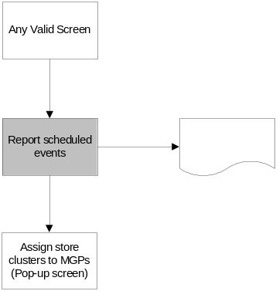

Screen Layout
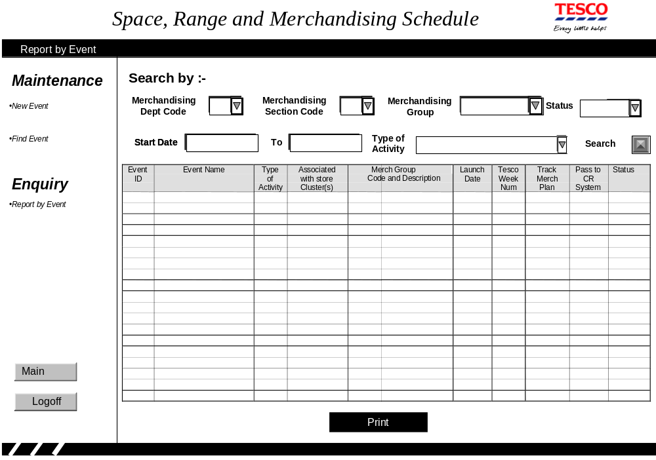
On entry to this screen the cursor should be positioned in the Merchandising Department code box and none of the buttons should be set as the default button.

The screen should be displayed in launch date / merchandising group sequence.

Field Descriptions
Field | Description | Comments
Merchandising department code - 1 char | A drop down box of all merchandising departments that are on the MGM system.
Merchandising section code - 1 char | A drop down box of all Merchandising section codes that are on the MGM system and within the selected departments.
Merchandising group code - 3 char | A drop down box of all Merchandising group codes that are on the MGM system
Status - 11 chars | A drop down box listing the five status values known to the User: 'Pending', 'Open', 'Approved', 'Unlocked' and 'Authorised' | If the User selects a ranging events status  the report only lists the ranging events with the relevant status  'Pending' lists 'Pending'  'Open' lists 'Pre-Ranging'  'Approved' lists 'Ready', 'CRST' and 'In Progress'  'Unlocked' lists 'Un-approved'  'Authorised' lists 'Authorised'
Start Date - as screen standards | The start date of the search | The search is inclusive of this date. This should default to the current date
To Date - as screen standards | The end date of the search | The search is inclusive of this date. If nothing is entered in the end date then only report events that launch on the start date
Type of activity - 30 chars | Describes the type of activity that is being launched for this event. E.G. NEW, UPDATE, REFRESH, AUDIT | The list of valid activity types is maintained within the schedule parameters
Event ID - 8 chars | The event id for each event that meets the search criteria
Event Name - 20 chars, can wrap to 2 lines, if longer than 40 chars replace last 3 chars with … and the full name should be available via a tool tip | The event name
Type of Activity - 10 chars, can wrap to 2 lines, if longer than 20 chars replace last 3 with … and the full name should be available via a tool tip | Describes the type of activity that is being launched for this planning group event. E.G. NEW, UPDATE, REFRESH, AUDIT.
Associated with store clusters - 3 chars | If there are any store cluster associated with this planning group event then this column contains 'Yes' | The user can transfer to the 'Assign store clusters to a planning group' screen by clicking yes
Merchandising Group code and description - 18 chars, can wrap to 2 lines | The merchandising groups codes and descriptions associated with an event. | This is blank if there aren't any merchandising groups associated with the event.
Launch Date - as screen standards | The launch date for a merchandising group associated with this event. | If there are no merchandising groups this is the event launch date.
Tesco Week number - as screen standards | The system automatically converts the launch date to a Tesco week number. | The first day of the Tesco week is defined within the overall flight deck parameters.
Assigned MGP -Track Merch Plan - 1 char | An indicator to show if the implementation of this merchandising event should be tracked on the I4B report
Assigned MGP -Pass to CR system - 1 char | An indicator to show if this entry on the schedule should be passed to the CR system so that the sore receives the Managing Your Range report
Status - 11 chars | The status of the ranging event | This is reported as:  'Pending' for 'Pending'  'Open' for 'Pre-Ranging'  'Approved' for 'Ready', 'CRST' and 'In Progress'  'Un-apporved' for 'Unlock'  'Authorised' for 'Authorised'

Description of Screen Function
The Ranging Controls team uses this screen to enquire on which merchandising groups are due to launch within a specified time period. The screen is initially empty (except for the start date, which defaults to the current date) and is populated by entering any combination of details in the Search boxes. Entering the current date in the start date box and entering a date of 31/12/2099 in the end date box will produce a report of all future events on the SCHEDULE.

The user can view any store clusters by clicking the 'Yes' link in the 'Associated to Store clusters' column which opens the 'Assign store clusters to a planning group event' screen.

The information on the screen can be printed via the PRINT button.

The contents of the screen can be sorted by clicking on the column heading.

Validation and error handling

Field | Validation
Event ID | If not numeric error 2
Event name | If blank error 3
Start date | If invalid dd/mm/yy date format error 4
To date | If invalid dd/mm/yy date format error 4
 | If no event found that matches search criteria error 15

Upload Menu

Navigation
The Upload menu is selected from the main flight-deck menu.
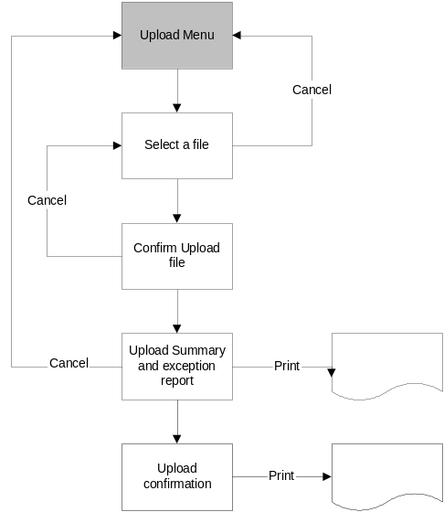

Screen Layout
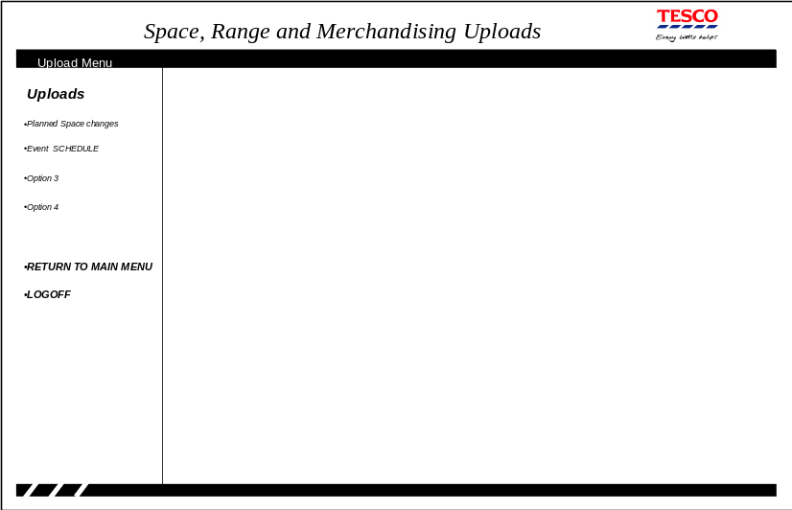

On entry to this screen the cursor does not need to be positioned and none of the buttons should be set as the default button.

Field Descriptions
There are no fields entered or displayed on this first screen.

Description of Screen Function
The first screen is a menu allowing the User to select the required Upload.

Validation and error handling
This screen doesn't require any specific validation.

Security considerations
This screen can only be entered if the user has 'Super User' access to the Ranging control system and the option to upload the schedule is only available if the user has 'Super User' access to the SCHEDULE application.

Select File
This screen allows the user to select the file to be upload to the SCHEDULE

Navigation
The screen is entered by selecting the Bulk SCHEDULE load from the UPLOAD screen

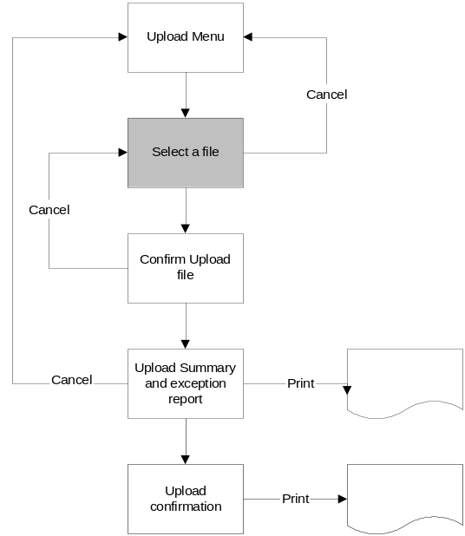

If the User selects the CANCEL button on this screen they are returned to the UPLOAD menu screen.

Screen Layout
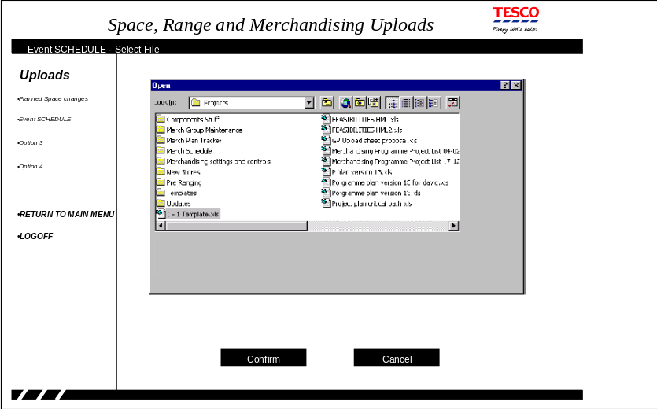

On entry to this screen the cursor should be positioned in the file name box and the 'Confirm' button should be set as the default button.

The screen consists of the standard Windows Disk Navigation screen to allow the User to navigate to the file they wish to upload.

Field Descriptions
Field | Description | Comments
File name | The file that the User wants to load to the SCHEDULE | Selected by the standard Windows Disk navigation screen

Description of Screen Function
The screen allows the User to select the file to be loaded to the SCHEDULE.

Validation and error handling
This screen doesn't require any specific validation.

Spreadsheet format
The spreadsheet used to store the schedule before the bulk load process must contain at least the following columns: -
- Event Name
- Launch Date
- Type of Activity
- Merchandising group
- Merchandise Plan Tracking Indicator
- CR system indicator

The Upper Case value of the Event name is used to group together rows into the merchandising events.

Once the spreadsheet is ready to be loaded it must be saved in Event Name, Launch date sequence.

Confirm Upload File
This screen allows the user to check that the correct file has been selected for the SCHEDULE load.

Navigation
Choosing a file from the SELECT file screen brings the user to this screen.

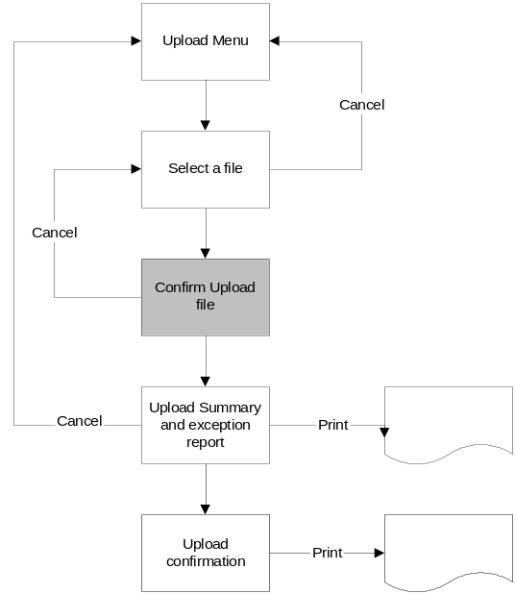

If the User selects the CANCEL button on this screen they are returned to the SELECT file screen so the correct file can be chosen.

Screen Layout
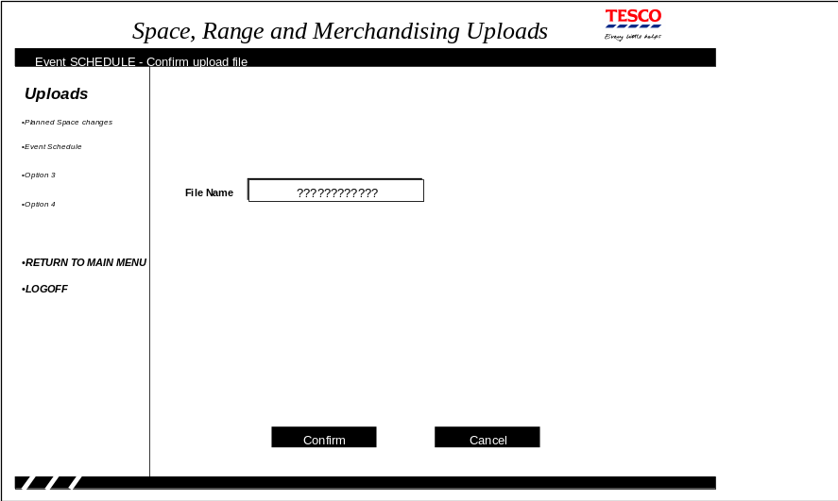
On entry to this screen the cursor should be positioned in the file name box and the 'Confirm' button should be set as the default button.

Field Descriptions
Field | Description | Comments
File name | The file that the User wants to load to the SCHEDULE | The file name cannot be changed on this screen

Description of Screen Function
The screen shows the file selected from the SELECT file screen so that the user can confirm that they have chosen the correct file. When the User confirms that this is the correct file the system validates the file contents and produces a report of any errors found.

Validation and error handling
Screen validation
Field | Validation
File name | If the file doesn't exist then error 17

Spreadsheet validation
Field | Validation
Event Name | If blank error 52  If the name is too long then error 9
Launch Date | If invalid dd/mm/yy date format then error 4  If not in the future then error 5  If to far in the future based on the control parameter then error 6  If within the minimum lead time based on the control parameter then error 31.  If the date is not greater than the latest launch date for a merchandising group already on the schedule then error 48  If the number of days between the earliest launch date and the latest launch date for an event is more than the limit on the overall event parameter from the control parameter then error 32.
Type of Activity | If doesn't exist on the control parameters then error 49 or is 'Essential Product launches'  (This would therefore be rejected if left blank)  If the activity type is inconsistent within a planning group event then reject the every row for the planning group event with error 36
Merchandising group | If it is not going to be live on the launch date then error 50  If an event contains a blank merchandising group and also contains more than 1 row then error 54  If a merchandising group appears more than once for the same planning group event then error 43
Merchandise Plan Tracking Indicator | If it is not 'Y' or 'N' or blank then error 51
CR system indicator | If it is not 'Y' or 'N' or blank then error 53
 | If the spreadsheet isn't in EVENT Name / Date sequence then the entire upload is rejected with error 56.
 | If a merchandising group appears on the upload file more than once for the same date then reject both rows with error 61

When reading the input file every row where the Upper Case version of the EVENT name matches the Upper Case version of the EVENT name on another row should be considered as part of the same Event. This means that if there were three rows on the spreadsheet with the following event names
Soups and canned veg, SOUPS AND CANNED VEG' and 'Soups & canned veg' then the first two rows would be part of one event while the third row would be a separate event.

If any errors are found with the spreadsheet details every row for the EVENT is reported on the Upload summary and exception report once every row on the spreadsheet has been checked. Any row that is just reported because another row for the EVENT has an error should be reported with error 55.

Upload Summary and Exception Report
The screen reports any errors in the spreadsheet that the user wants to load into the SCHEDULE.

Navigation
Once the user has confirmed that the correct file was selected for the upload the details are validated and they can view the results on this screen.

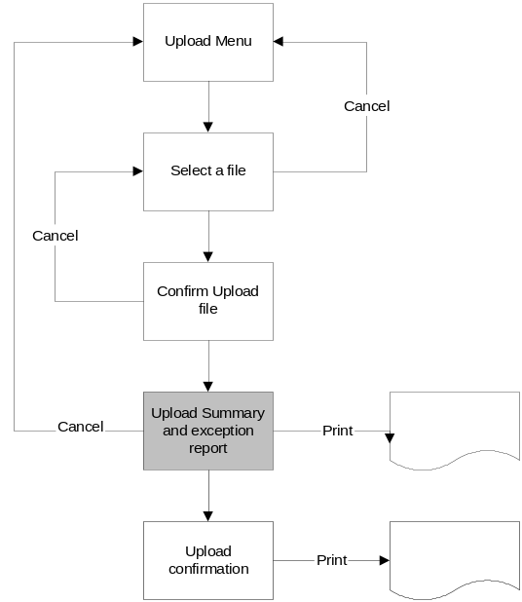

If the User selects the CANCEL button on this screen they are returned to the main Upload menu screen.

Screen Layout
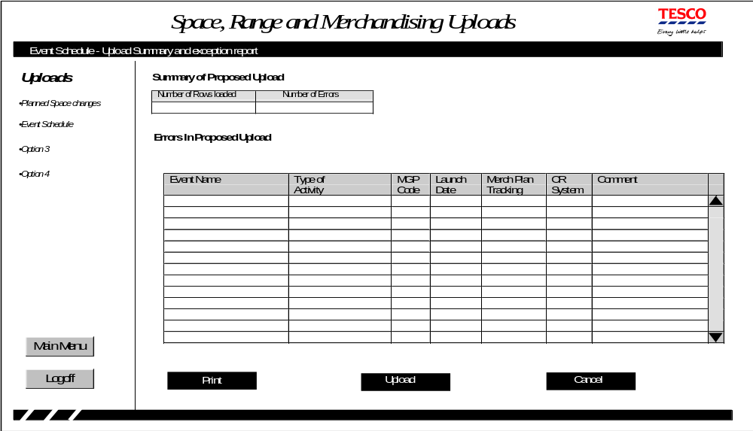
On entry to this screen the cursor does not need to be positioned and the 'Cancel' button should be set as the default button.

Field Descriptions
Field | Description | Comments
Number of Rows Loaded - 5 chars | The number of rows on the spreadsheet
Number of Errors - 5 chars | The number of rows on the spreadsheet that contained errors
Event Name`- 20 chars, can wrap to 2 lines, if longer than 40 chars replace last 3 chars with … and the full name should be available via a tool tip | The Name of the event from the spreadsheet
Type of Activity - 10 chars, can wrap to 2 lines, can wrap to 2 lines, if longer than 20 chars replace last 3 chars with … and the full name should be available via a tool tip | The type of activity from the spreadsheet
MGP Code - 3 chars | The merchandising code from the spreadsheet | This may be blank
Launch Date - as screen standards | The Launch date from the spreadsheet
Merchandise Plan Tracking - 1 char | The merchandise plan tracker indicator from the spreadsheet
CR System - 1 char | The interface to Cr system indicator from the spreadsheet
Comment - 20 chars, can wrap to 2 lines, can wrap to 2 lines, if longer than 40 chars replace last 3 chars with … and the full comment should be available via a tool tip | Description of the error | The reasons for the errors are described in 6.2.11.5 and the text of the error is in 7.2.1 Error Codes

Description of Screen Function
The screen lists any errors found when validating the schedule spreadsheet prior to the user uploading the information to the schedule. If any errors are found with the spreadsheet data the user must CANCEL the upload and correct the errors on the spreadsheet.

The error report can be printed via the PRINT button.

The contents of the screen can be sorted by clicking on the column heading.

While this screen is active it must be impossible for anybody to change the file being loaded until either the User has completed the load or selected Cancel from this screen.

Validation and error handling
If any errors have been reported on this screen the UPLOAD button must be 'greyed' out as the User is only allowed to continue with the upload if there are no errors in the spreadsheet.

Upload Confirmation and Error Report
This screen reports the results of loading the spreadsheet to load the SCHEDULE.

Navigation
Once the user has validated the spreadsheet and corrected any errors they can continue with the actual load. Once the load has completed they will see the results on this screen.

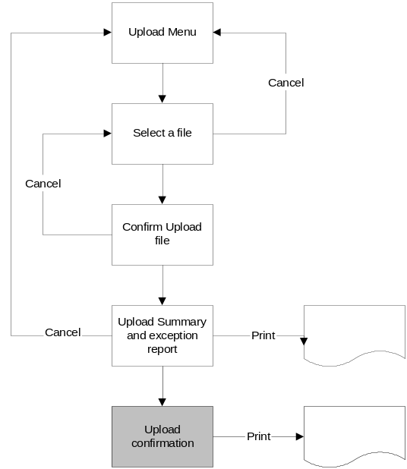

Once the User has reviewed the upload report they can exit the screen using one of the options on the left-hand menu.

Screen Layout
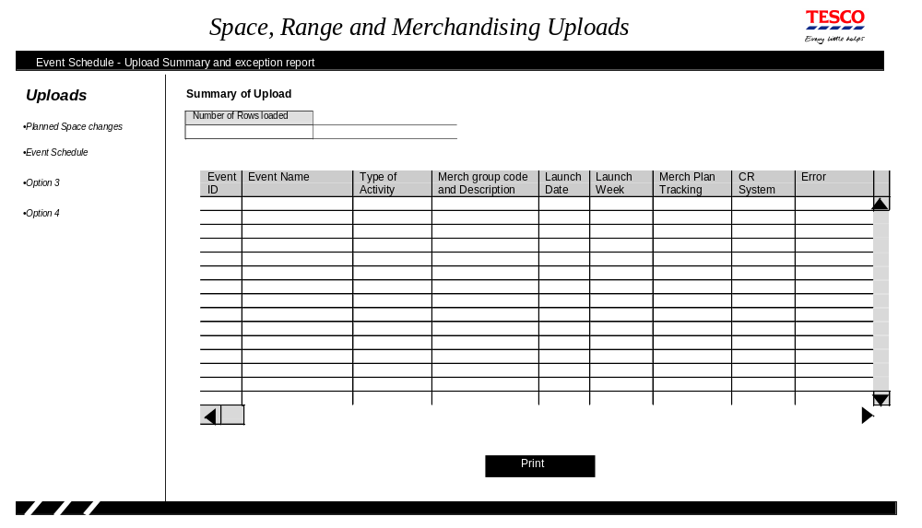On entry to this screen the cursor does not need to be positioned none of the buttons should be set as the default button.

Field Descriptions
Field | Description | Comments
Number of Rows Loaded - 5 chars | The number of rows on the spreadsheet
Event ID - 8 chars | The system generated identifier for the event | This is generated by the system in the format XXYXXMXX
Event Name`- 20 chars, can wrap to 2 lines, can wrap to 2 lines, if longer than 40 chars replace last 3 chars with … and the full name should be available via a tool tip | The Name of the event from the spreadsheet
MGP Code and Description - 18 chars, can wrap to 2 lines, can wrap to 2 lines, if longer than 36 chars replace last 3 chars with … and the full description should be available via a tool tip | The merchandising code from the spreadsheet | This may be blank
Launch Date - as screen standards | The Launch date from the spreadsheet
Launch week - as screen standards | The Tesco week of the Launch | The first day of the week is defined within the overall flight parameters
Type of Activity - 10 chars, can wrap to 2 lines, can wrap to 2 lines, if longer than 20 chars replace last 3 chars with … and the full name should be available via a tool tip | The type of activity from the spreadsheet
Merchandise Plan Tracking - 1 char | The merchandise plan tracker indicator from the spreadsheet | If the spreadsheet value is blank then the default value should be shown
CR System - 1 char | The interface to CR system indicator from the spreadsheet | If the spreadsheet value is blank then the default value should be shown
Error - 20 chars, can wrap to 2 lines, can wrap to 2 lines, if longer than 40 chars replace last 3 chars with … and the full error description should be available via a tool tip | Description of the error | The reasons for the errors are described in 6.2.11.5 and the text of the error is in 7.2.1 Error Codes

Description of Screen Function
The spreadsheet will not be validated as part of the processing for this screen as the previous screen will already have ensured that all entries on the spreadsheet are valid. During this upload the system will calculate the following details: -

Event ID | - | After the details have been confirmed the system generates the Planning Group Event ID in the format XXYXXMXX where: -  - XX - is the hexadecimal equivalent of a random number between 0 - 255  - Y - is the last character of the year the event was added to the schedule  - M - is the hexadecimal equivalent of the month the event was added to the schedule.  If the generated Planning Group Event ID already exists on the schedule another one will be generated until one is found that hasn't already been used on the Schedule
Event Name | - | Converted to Upper Case
Event Launch Date | - | The earliest launch date entered for the event
Event Week number | - | The event launch date converted to Tesco week number. The first day of the week is defined within the overall flight parameters.
Event activity type | - | The activity type of the first event within the planning group event
Merchandising group week number | - | The merchandising group launch date converted to Tesco week number. The first day of the week is defined within the overall flight parameters.
Merchandise Plan Tracking | - | If the value on the spreadsheet is blank then use the default value for this activity type from the parameter file.
CR system | - | If the value on the spreadsheet is blank then use the default value for this activity type from the parameter file.
Ranging Event Status | - | Pending

The load report can be printed via the PRINT button.

The contents of the screen can be sorted by clicking on the column heading.

Validation and error handling
There is no validation required on this screen.

Reports
The reports illustrated within the BSD do not represent the final version of the report but do identify all of the information that will be on the final report.

Report scheduled events

Navigation
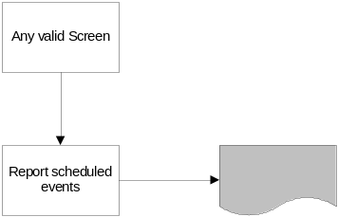

The report can be produced anytime the user wishes to have a hard copy by clicking the Print button on the Report scheduled events screen.

Report Layout
Space Range and Merchandising Schedule
Selected Events only

Planning Group Event XXYXXMXX XXXXXXXXXXXXXXXXXX for Activity Type XXXXXX
is Approved for launch dd/mm/yy (week nn)
It applies to ENGLAND METROS
SCOTLAND AND WALES EXTRA
Store clusters

Planning Group Event XXYXXMXX XXXXXXXXXXXXXXXXXX for Activity Type XXXXXX
for launch dd/mm/yy (week nn)
It applies to ALL Store Clusters
and
Merchandising Launch Tesco Track CR
Group Date Wk. Status Plan Sys
G1A Canned Vegatables dd/mm/yy 07/14 Pending Y Y
G1B Soup dd/mm/yy yy/ww Approved Y Y

Planning Group Event XXYXXMXX XXXXXXXXXXXXXXXXXX for Activity Type XXXXXX
is Pending for launch dd/mm/yy (week nn)
It applies to ALL Store Clusters

and no merchandising groups are currently assigned

The report should be in the same sequence as the screen it was requested from.

When reporting a Space Event the status is always 'Approved' and the section listing the Merchandising groups assigned to the Planning Group must be suppressed.

When reporting a merchandising planning group event that doesn't have any merchandising groups currently assigned to it the status is always 'Pending'.
Field Descriptions
Field | Description | Comments
Event ID - 8 char | The event id for the event being reported
Event Name - 60 char | The event name
Activity Type - 30 char | Describes the type of activity that is being launched for this planning group event. E.G. NEW, UPDATE, REFRESH, and AUDIT.
Associated store clusters | The store clusters associated with the event. | The report will either ALL store clusters or list the cluster associated with the event
Merchandising Group -3 chars for the merchandising group code and 31 for the description | The merchandising groups and merchandising group names associated with an event. | The report will either list each of the merchandising groups assigned to a planning group event or if not have been assigned the report will state 'no merchandising groups currently assigned'
Launch Date - same as screen standards | The launch date for a merchandising group associated with this event. | Details are only reported if a merchandising group is assigned to the planning group event.
Tesco Week number - same as screen standards | The system automatically converts the launch date to a Tesco week number. | The first day of the Tesco week is defined within the overall ranging controls parameters. Details are only reported if a merchandising group is assigned to the planning group event.
Status - 11 char | The current status of the event | If ranging event status is 'Pending' it is shown as 'Pending'. If it is 'Pre-Ranging' it is shown as 'Open'. If it is 'Ready', 'CRST', 'In Progress' it is shown as 'Approved'. If it is 'Authorised' it is shown as 'Authorised'. If it is 'Unlock' it is shown as Un-approved'. If it is 'Cancelled' is is shown as 'Cancelled'.
Track Plan - 1 char | An indicator to show if the implementation of this merchandising event should be tracked on the I4B report | Details are only reported if a merchandising group is assigned to the planning group event.
CR System - 1 char | An indicator to show if this entry on the schedule should be passed to the CR system so that the sore receives the Managing Your Range report | Details are only reported if a merchandising group is assigned to the planning group event.

Report Description
The report provides a hard copy of the SCHEDULE for the events selected via the on-line system.

Report a single event

Navigation
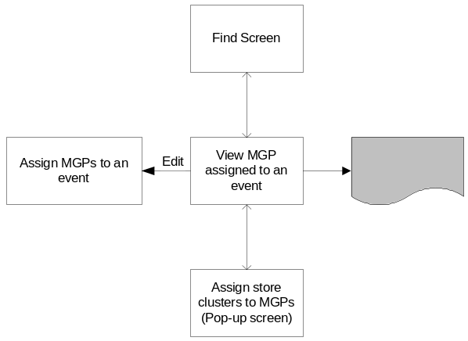

The report can be produced anytime the user wishes to have a hard copy by clicking the Print button on the View merchandising groups assigned to an EVENT screen.

Report Layout
Space Range and Merchandising Schedule

Planning Group Event XXYXXMXX XXXXXXXXXXXXXXXXXX for Activity Type XXXXXX
for launch dd/mm/yy (week nn)
It applies to ALL Store Clusters
and
Merchandising Launch Tesco Track CR
Group Date Wk. Status Plan Sys
G1A Canned Vegatables dd/mm/yy 07/14 Pre-ranging Y Y
G1B Soup dd/mm/yy yy/ww Authorised Y Y

This report is exactly the same format as the report listing selected events. The only difference is in the heading.

When reporting a Space Event the status is always 'Approved' and the section listing the Merchandising groups assigned to the Planning Group must be suppressed.

When reporting a merchandising planning group event that doesn't have any merchandising groups currently assigned to it the status is always 'Pending'.

Field Descriptions
Field | Description | Comments
Event ID - 8 chars | The event id for the event being reported
Event Name - 60 chars | The event name
Activity Type - 30 chars | Describes the type of activity that is being launched for this planning group event. E.G. NEW, UPDATE, REFRESH, AUDIT.
Associated store clusters | The store clusters associated with the event. | The report will either show ALL store clusters or list the cluster associated with the event
Merchandising Group - 3 chars for the code and 31 chars for the description | The merchandising groups and merchandising group names associated with an event. | The report will either list each of the merchandising groups assigned to a planning group event or if not have been assigned the report will state 'no merchandising groups currently assigned'
Launch Date - as screen standards | The launch date for a merchandising group associated with this event. | Details are only reported if a merchandising group is assigned to the planning group event.
Tesco Week number - as screen standards | The system automatically converts the launch date to a Tesco week number. | The first day of the Tesco week is defined within the overall ranging controls parameters. Details are only reported if a merchandising group is assigned to the planning group event.
Status - 11 chars | The current status of the event | If ranging event status is 'Pending' it is shown as 'Pending'. If it is 'Pre-Ranging' it is shown as 'Open'. If it is 'Ready', 'CRST', 'In Progress' it is shown as 'Approved'. If it is 'Authorised' it is shown as 'Authorised'. If it is 'Unlock' it is shown as Un-approved'. If it is 'Cancelled' is is shown as 'Cancelled'.
Track Plan - 1 char | An indicator to show if the implementation of this merchandising event should be tracked on the I4B report | Details are only reported if a merchandising group is assigned to the planning group event.
CR System - 1 char | An indicator to show if this entry on the schedule should be passed to the CR system so that the sore receives the Managing Your Range report | Details are only reported if a merchandising group is assigned to the planning group event.

Report Description
The report provides a hard copy of the SCHEDULE for the event currently being viewed.

Upload Exception Report

Navigation
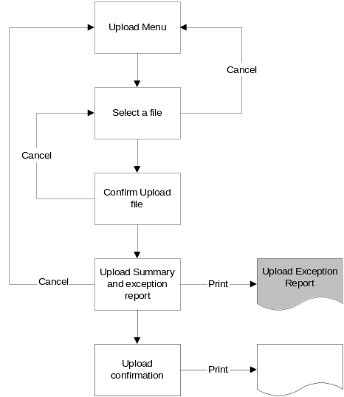

The report is produced anytime the user wishes to have a hard copy by clicking the Print button on the Upload Summary and exception screen.

Report Layout
Space Range and Merchandising Schedule
Spreadsheet Upload Exceptions
Event Name Merch. Launch Activity Track CR Comment
Group Date Type Plan System

The report should be in the same sequence as the screen it was requested from.

Field Descriptions
Field | Description | Comments
Event Name`- 60 chars | The Name of the event from the spreadsheet
MGP Code - 3 chars | The merchandising code from the spreadsheet | This may be blank
Launch Date - as screen standards | The Launch date from the spreadsheet
Type of Activity - 30 chars | The type of activity from the spreadsheet
Merchandise Plan Tracking - 1 char | The merchandise plan tracker indicator from the spreadsheet
CR System - 1 char | The interface to CR system indicator from the spreadsheet
Comment - 20 chars | Description of the error | The reasons for the errors are described in 6.2.11.5 and the text of the error is in 7.2.1 Error Codes

Report Description
The report provides a hard copy of the errors found when validating the schedule spreadsheet prior to the upload in the same sequence as the screen.

Upload Confirmation Report

Navigation
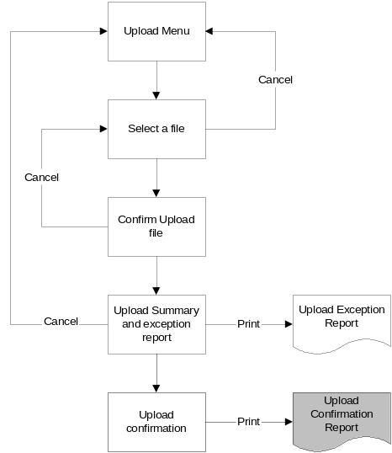

The report is produced anytime the user wishes to have a hard copy by clicking the Print button on the Upload Confirmation and error screen.

Report Layout
Space Range and Merchandising Schedule
Spreadsheet Upload Confirmation
Event Name Merchandising Launch Launch Activity Track CR
ID Group Date Week Type Plan System

Number of Rows loaded 9999

The report should be in the same sequence as the screen it was requested from.

Field Descriptions
Field | Description | Comments
Number of Rows Loaded - 5 chars | The number of rows on the spreadsheet | This only appears on the last page of the report
Event ID - 8 chars | The system generated identifier for the event
Event Name`- 60 chars | The Name of the event from the spreadsheet
Merchandising Group - 3 chars for the code and 31 for the description | The merchandising code from the spreadsheet and the description from the MGM system | This may be blank
Launch Date - as screen standards | The Launch date from the spreadsheet
Launch week - as screen standards | The Tesco week of the Launch | The first day of the week is defined within the overall flight parameters
Type of Activity - 30 chars | The type of activity from the spreadsheet
Merchandise Plan Tracking - 1 char | The merchandise plan tracker indicator from the spreadsheet
CR System - 1 char | The interface to CR system indicator from the spreadsheet

Report Description
The report provides a hard copy of the schedule spreadsheet details that were loaded to the SCHEDULE application in the same sequence as the screen.

Other Processes

Creating Essential Product Launch events
Each weekend the system will automatically create Planning group events that may be used for Essential Product launches. These planning group events must be on the schedule and available to the Ranging System by 07:00 Monday morning.

Every weekend the system automatically creates a planning group event for every merchandising department within the MGM system with a launch date of the Monday of week + 4 (the actual number of weeks is controlled by a parameter). For each planning group created the system will create a ranging event for each merchandising group live on MGM on the launch date. This means that if the process is running over the weekend Saturday 1st July then the launch date will be Monday 31st July 2006 assuming that the parameter is four weeks. Therefore every merchandising group that will still be live in MGM on the 31st July will have a new ranging event created. Each generated ranging event will be assigned the next sequential ranging event id when it is added to the database.

The only exception to this is that if a ranging event for a merchandising group already exists on the schedule for the same launch date then the system will not need to create an Essential Product launch ranging event.

Each planning group will have a random Planning Group Event ID generated as well as the sequential planning group id used as a database key. The random planning group Id is in the format ZWYXXMXX where: -

- Z - is the constant Z
- W - is the hexadecimal equivalent of a random number between 0 - 15
- XX - is the hexadecimal equivalent of a random number between 0 - 255
- Y - is the last character of the year the event was added to the schedule
- M - is the hexadecimal equivalent of the month the event was added to the schedule.

If the generated Planning Group Event ID already exists on the schedule another one will be generated until one is found that hasn't already been used on the Schedule.

Each Planning group generated by this process will be given a Planning group name in the format 'Essential Product Launch - aaaaaaaaaaaaa wknn' where aaaaaaaaaaaaa represents the description of the merchandising department group prefixed by the merchandising department code and nn is the launch week.

The status of the each ranging group created is set to 'Ready' to enable the details to be passed to the Ranging System.

Deleting Essential product launch events.
During the weekend processing any essential product launch ranging event that hasn't been authorised should be flagged for deletion 4 weeks after the launch date. The actual number of weeks is controlled by a parameter. This means that if the process is running over the weekend Saturday 1st July then the launch date for deletion is Monday 5th June 2006 assuming that the parameter is four weeks.

If all of the ranging events for a planning group event have been flagged for deletion then the planning group should also be flagged for deletion.

CR daily interface
All of the future ranging events on the schedule where the infrastructure has been approved (status is 'Ready', 'CRST', 'In Progress', or 'Authorised') are passed to the CR system each evening. The CR system will continue to combine the schedule with the store merchandising group authorisation details to determine if the store receives the Managing Your Range report or the Weekly Range Change Update Report.

The CR system will not receive details of any of the space events or 'Essential Product Launches', this means that the format of the interface remains exactly the same as the current interface.

Data Warehouse interface
The Data Warehouse requires a daily interface of the Space, Range and Merchandising schedule. This interface will include all future entries on the schedule (both ranging and space events) irrespective of whether the event infrastructure has been approved or not. The interface will also include an indicator to show whether the event was for all store clusters or just selected store clusters, it will not however identify which store clusters were impacted by the event. The Data Warehouse interface includes details for all 'Essential Product launch' events but these are excluded from the processing used by the I4B - Out of Cycle product launch report to determine if a product was launched as part of an event on the SCHEDULE.

The Data Warehouse tables must hold a historical view of the Space, Range and Merchandising schedule as well as the current version of the schedule to allow the users to see what was on the schedule at anytime during the previous two years.

Range ODS
The Range ODS requires a daily interface of the Space, Range and Merchandising schedule. This interface will contain both space and merchandising events (including 'Essential Product launches') irrespective of whether they have been approved.

GR daily interface
The GR system requires an interface of all the approved (status is 'Ready', 'CRST', 'In Progress', or 'Authorised') ranging events irrespective of the launch date. This interface will not differentiate between events for ALL store clusters and those for only selected store clusters.

STANDARDS

Screen & Report Design
For the standards to be adopted for screen and report design see the design documents provided separately.

Error Handling

Error Codes
The error messages can be split intosix different types of message: -
A | - | Advisory messages
E | - | Error Messages
I | - | Information Messages
Q | - | Questions
R | - | Report Messages
W | - | Warning Messages

Each of the different types of error message is reported on slightly differently and provides the user with different options. These are described in section 7.2.2 Message Handling.

Common system message
Msg. No. | Message | Trigger | Type of Message
1 | Data entered must be alphabetic | Numeric data detected in alpha field | E
2 | Data entered must be numeric | Alpha characters detected in numeric field | E
3 | Enter data into highlighted fields | Incomplete data | E
4 | Invalid date format | Date validation failed | E
5 | Invalid date. Date must be greater than today | Failed date validation – date too old | E
6 | Invalid date. Too far in the future | Date validation failed – date too far in future | E
7
8 | Description already exists | Description validation failed | E
9 | Field is too long | Data entered is longer than expected | R
10 | The description already exists. Do you want to continue? | Duplicate description found | W
11 | Selecting this option will lose all unconfirmed changes. Do you want to continue? | Another option selected from the navigation menu or selecting cancel or main menu or logoff prior to pressing the “proceed” button | W
14 | Are you sure? | To confirm that selected action is correct | W
15 | No details found that match the search criteria | No details found that match the search criteria | A
16 | Invalid Tesco year/week | Invalid Tesco year and week | E
17 | File not found | The selected file doesn't exist | A
20 | Insufficient Security Access | The user does not have the correct security access for the requested action | A
30 | Action successful | All data successfully validated and processed | I

SCHEDULE Specific Messages

Msg. No. | Message | Type | Used on Screen | Ref. Section | Trigger
31 | Warning - Date within minimum lead time | W | Find Screen  Enter a new event Screen  Assign merchandising groups to a planning group event | 6.2.2  6.2.3  6.2.4 | The launch date is less than the parameterised minimum lead time parameter in the future
31 | Warning - Date within minimum lead time | R | Confirm Upload File | 6.2.11
32 | Error - Merchandising group launch date must be within x days of the event launch date | E | Assign merchandising groups to a planning group event | 6.2.4 | The launch date for a merchandising group is more than the parameterised number of days past the event launch date.
32 |  | R | Confirm Upload File | 6.2.11
33 | All ranging events must be removed before the planning group can be deleted | A | Find Screen | 6.2.2 | The user is trying to delete a planning group event that still contains active ranging events
34 | Event YYYYMMDDnnn successfully created.  Do you wish to assign merchandising groups and/or store clusters | Q | Enter a new event Screen | 6.2.3 | The user has created a new event and is given the option to set-up the merchandising groups and/or store clusters
35 | Error - Merchandising group already exists for planning group xxxxxxxx for the same launch date | E | Assign merchandising groups to a planning group event | 6.2.4 | The same merchandising group appears more than once for a the same launch date across different planning group events
36 | Inconsistent activity type for this planning group | R | Confirm Upload File | 6.2.11 | There is more than one activity type specified for a planning group event.
37 | Warning - Selected store clusters will be removed if you continue - Do you wish to continue? | W | Assign merchandising groups to a planning group event | 6.2.4 | Clicking ALL store clusters after SELECTED store clusters had been chosen
38 | Warning - Merchandising activity launch is within x days. Do you want to proceed | W | Assign merchandising groups to a planning group event  Assign store clusters to planning group event | 6.2.4  6.2.5 | There is an attempt to amend the launch date of an event within the parameterised minimum lead time
39 | Error - No store cluster selected | E | Assign store clusters to planning group event | 6.2.5 | The confirm button was selected on the assign store cluster screen but no clusters were selected
40 | Error - Cannot cancel the merchandising ranging event as the launch is within 3 weeks | A | Assign merchandising groups to a planning group event | 6.2.4 | The user is trying to remove a merchandising group from a planning group event within 3 weeks of the launch date.
41 | Error - Merchandising Hierarchy changes still exist. They must be removed before the merchandising group | A | Assign merchandising groups to a planning group event | 6.2.4 | The user is trying to remove a merchandising group from a planing event but there are still changes in the MGM system associated to the planning group event for this merchandsiing group
42 | Warning - Changing the launch date for (list of MGPS) impacts planning group events (list of events) | W | Assign merchandising groups to a planning group event | 6.2.4 | By changing the launch date of the ranging event the sequence of ranging events for this merchandising group has now changed.
43 | Merchandising group appears more than once for planning group xxxxxxxxxxxxxxx | R | Confirm Upload File | 6.2.11 | The same merchandising group appears more than one for a planning group event.
45 | Warning - You are about to delete an Event. This operation cannot be undone. Do you wish to contine | W | Delete or view an event on the schedule | 6.2.6 | The user is deleting an event
47 | Warning - Changing the planning group launch date will change the launch date of all ranging events in the Planning Group.  Do you wish to Continue? | W | Assign merchandising groups to a planning group event | 6.2.4 | The planning group launch date is being changed
48 | Error - Event cannot be loaded by the bulk load as later events already exist on the schedule | R | Confirm Upload File | 6.2.11 | The event launch date on the spreadsheet is earlier than the latest launch date already held on the schedule
49 | Error - Activity type invalid | R | Confirm Upload File | 6.2.11 | The activity type isn't held on the schedule parameters or thw activity type is 'Essential Product Launches'
50 | Error - Merchandising group is not live on the event launch date | R | Confirm Upload File | 6.2.11 | The merchandising group won't be live on the launch date according to the MGM system
51 | Error - Invalid merchandise plan tracker indicator | R | Confirm Upload File | 6.2.11 | The merchandise tracker indicator contains a value other than 'Y', 'N' or blank
52 | Error - Missing event name | R | Confirm Upload File | 6.2.11 | The event name on the spreadsheet is missing
53 | Error - Invalid CR system indicator | R | Confirm Upload File | 6.2.11 | The CR system indicator contains a value other than 'Y', 'N' or blank
54 | Error - An event can not contain both merchandising group details and a blank merchandising group entry | R | Confirm Upload File | 6.2.11 | The spreadsheet contains an entry for an event name that specifies a merchandising group as well as a row for the same event name without a merchandising group.
55 | Error - Other rows for this EVENT have errors | R | Confirm Upload File | 6.2.11 | This row doesn't contain any errors but other rows for this event contain errors
56 | Error - Spreadsheet isn't in the correct sequence | A | Confirm Upload File | 6.2.11 | The spreadsheet isn't in EVENT name / launch date sequence.
58 | Must select a row first | I | Find Screen | 6.2.2 | The user has clicked on an 'ACTION' button on the FIND screen without selecting an entry first.
61 | Attempt to upload merchandising group X9X more than once for dd/mm/yy | R | Confirm Upload File | 6.2.11 | The spreadsheet to be uploaded contains more than entry for the same merchandising group and launch date.
62 | Warning - Range in Progress will be delete | W | Assign merchandising groups to a planning group event | 6.2.4 | User is removing a merchandising group from a planning event and infrastructure work has already started
63 | These overlays will start on this event  Aaaaa  Bbbbb  These overlays will finish on this event  Cccccc  Ranging exceptions will start on this event for n stores  Ranging exceptions will end on this event for n stores  Do you wish to carry these forward to the next event on <date> or delete them | Q | Assign merchandising groups to a planning group event | 6.2.4 | User is removing a merchandising group from a planning event and there are pre-ranging changes associated with this event that could be carried forward to another event on the schedule.

Message Handling
Each of the application error messages is handled as follows: -

Message Type |  | Reported by | Actions
Error | E | Field(s) in error are highlighted and a red asterisk place to the left of each.  Alert box displayed in red at the top of the screen | The fields in error have to be corrected and re-validated before the message is removed and the processing continued with.  (Alternatively the user may chosse to logoff or navigate elsewhere instead)
Information | I | Either: an informational message at the bottom of the screen or  A message box that times out automatically | No action required. Message to be removed… (tba)
Advisory | A | Alert box with an advisory message | User will need to acknowledge the message by clicking on OK before the message disappears
Report | R | Message on a report | Spreadsheet row won't be loaded to the SCHEDULE
Warning | W | Alert Box with the question:  Do you want to continue? Yes/No | If the reply is Yes: System completes the requested action  If the reply is No: System returns to the input screen to allow further change without completing the action

Login & Security
For the standards pertaining to the login procedure and security see the "Ranging Controls" BSD provided separately.

Deletion Processing
The general standard to be applied whenever data is being deleted within the Space, Range and Merchandising Schedule application is that it should only be flagged for deletion but not physically deleted until the associated Planning Group event would have been deleted by the normally housekeeping processing. This means that all processing that extracts information from the SCHEDULE for other systems and any enquires and reports within the SCHEDULE application must ignore any data flagged for deletion unless the BSD states differently.

It is essential that planning are not physically removed from the application during the same calendar month as they were added as it is necessary to check that the random planning group id generated by the system has not already been used.

NON-FUNCTIONAL REQUIREMENTS
A comprehensive list of the Non-functional requirements can be found in the separate document that describes each of the Non-functional requirements that need to be met across all of the Infrastructure projects.
Appendix A
Abbreviations

Abbrv. | Meaning | Description
BSD | Business System Design document | Document describing the business information and processes in the old and required for the new system
CR system | Continuous Replenishment | The store ordering system
CRDB | Commercial Range Data Base | A collection of I.T. files which hold all of the data needed to support the commercial range systems (excluding the ranging system)
CRS | Commercial Reporting System | The web-based management information reports developed for the commercial users.
GT&A | Global Technical & Architecture team | Advise on technical architecture and tools
I.T. | Information Technology | The department responsible for the support and development of computer systems within Tesco
KPI | Key Performance Indicator | An important measure to determine how well something is being done
MGP | Merchandising group | A three character code used to group products together so that they are sold from the same area in the store.
MI | Management Information | Any report used to either measure performance or help to define strategy.
NTH | New Tesco House | The Cheshunt Tesco Office
NWT | Natural Work team | A cross-functional team brought together to achieve a common objective
ODS | Operational Data Store | The I.T. system that holds all of the current information about a singles subject. E.G. product
SLA | Service Level Agreement | An agreement between the business users and I.T. support defining acceptable performance
UKBE | UK Business Expansion | The process of opening new stores and improving existing stores to increase sales.
WL6 | Work Level 6 | Senior Management level within Tesco

Appendix B
Definition of Terms

Term | Description
New Ranging System | The new system that will be used by the commercial team to define the products in each range
Business System Design document | Document describing the business information and processes in the old and required for the new system
Clothing Audit | The process in store to check the space being used for clothing
Commercial Range Data Base | A collection of I.T. files which hold all of the data needed to support the commercial range systems (excluding the ranging system)
Commercial Reporting System | The web-based management information reports developed for the commercial users.
Continuous Replenishment | The store ordering system
Critical Control Point | The final point in the process before the infrastructure changes are passed to the ranging system and other systems. All of the infrastructure changes must be complete and signed-off before this.
Data Warehouse playpen | An area of space set aside on the Data Warehouse where any of the authorised users can create or amend the data.
Day of week merchandising | The current merchandising schedule specifies which merchandising groups should be merchandised each week but allows stores the flexibility to merchandise any day during the week that is convenient. There is a proposal to change this process so that schedule specifies the day that a merchandising group should start. This has been termed day of week merchandising.
Event ID | A system generated number to identify each Planning group event on the schedule
Ranging Controls System | The portal that allows the user to access any of the new Infrastructure systems
Impact Report | A report created from the flight-deck applications to show the impact of all the infrastructure changes entered for an EVENT.
Information Technology | The department responsible for the support and development of computer systems within Tesco
Infrastructre report | A report created from the flight-deck applications to the infrastructure changes entered for an EVENT.
Infrastructure controls | The different controls and settings that need to be made to change the environment needed to support the new ranges created by the commercial teams.
Key Performance Indicator | An important measure to determine how well something is being done
Level Run Down | The term used to describe the objective of ensuring that all of the products have enough stock on the shelf to last until the next scheduled replenishment without holding more stock than necessary at the expense of another product.
Management Information | Any report used to either measure performance or help to define strategy.
Managing your Range Report | A store report that contains information about the merchandising groups undergoing change based on the merchandising schedule
Merchandise Plan Tracker | An existing report that measures how well stores implement merchandise plans
Merchandise Plan Tracker phase 2 | A new report under development to measure how well stores implement merchandise plans
Merchandising group | A three character code used to group products together so that they are sold from the same area in the store.
Mod / Fixture | The unit of shelving used in store to hold products
Natural Work team | A cross-functional team brought together to achieve a common objective
New Technology systems | The new systems will be built using a Web interface rather than the existing mainframe interface
New Tesco House | The Cheshunt Tesco Office
Operational Data Store | The I.T. system that holds all of the current information about a singles subject. E.G. product
Operations Team | The people who will be responsible for co-ordinating and managing the overall workflow to successfully launch a merchandising event.
Plan Group | The existing term used to group together items on the current merchandising schedule. This term is being replaced by the term Planning group event.
Planning Group Event | An entry on the SCHEDULE which groups together one or more pieces of work in store as there are dependencies between them
Pre-ranging | The application used to set up ranging attributes against stores and merchandising groups so that the store clusters can be defined for each range.
Produce Relay | A large amount of merchandising work in the Produce area due to season changes
Range Class | Each store merchandising group is assigned a range class based on the space available for the merchandising group and this is used to determine what products should be stocked.
Ranging event | A ranging activity affecting a single merchandising group on a single date. It is part of a planning group event.
Retail Range Tools | A set of reports used in store to manage the range of products stocked.
Retail Space, Range and merchandising KPI report | A report currently being developed so a store can review how well they are managing their Space, range and merchandising activities.
SCHEDULE | The Space, Range and Merchandising schedule
Service Level Agreement | An agreement between the business users and I.T. support defining acceptable performance
Space Audit | The activity in store to check that the right space is recorded for each merchandising group
Space Break | Sometimes just a number of mods. Otherwise, an number of mods deemed to be suitable for supporting a particular Range and achieving level run down
Space event | A space activity affecting a single merchandising group on a single date. It is part of a planning group event.
Store cluster | A group of Stores, grouped for ranging purposes. Also known as a Store Range Group. These are maintained at both store level and store merchandising group level
Supplementary Merchandising group | A merchandising group that contains products from two or more merchandising groups that is used in where the there isn't enough space in store to allocate at least 1 mod to each merchandising group.
Support Office | The Head Office department that ensures that the space, range and merchandising workload in store is acceptable.
Tracking Out of Cycle Changes report | A Commercial report designed to show if the commercial teams are keeping to the Business process for launching new ranges
UK Business Expansion | The process of opening new stores and improving existing stores to increase sales.
Weekly Range Change Update report | A store report that contains any range changes that impact a store when that merchandising group is not on the merchandising schedule.
Work Level 6 | Senior Management level within Tesco
Xansa | An external company used to help develop and support some of the systems used at Tesco.

